

Cardiovascular Health Monitoring System Using IOMT and AI

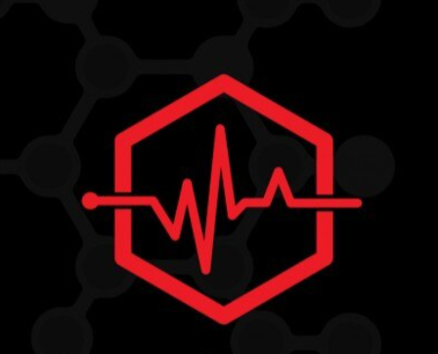

**By**

**Hala Abdeen Mostafa 202001392**

**Eman Gamal Hussien 202000135**

**Noor Allah Mohamed 202000119**

**Mina Mohab Sodek 202000557**

**Marwan Abd El Salam 20190086**

**Ahmed Khaled 201700264**

Under Supervision of

**Dr. Mahmoud Hanafy**

A Project submitted to

**Canadian International College**

In Partial Fulfillment of the

Requirements for the Degree of Bachelor in

**Electronics and Communication Engineering**

CANADIAN INTERNATIONAL COLLEGE

CAIRO, EGYPT

2024-2025

### Abstract

The integration of the Internet of Medical Things (IOMT) and artificial intelligence (AI) has revolutionized modern healthcare, providing real-time monitoring, advanced analytics, and improved accessibility to critical health data. This graduation project focuses on the development of an IOMT-enabled wearable device designed to monitor patients' vital signs using advanced sensors. The collected data is transmitted to a cloud-based AI model, which processes and classifies the patient's condition.

The AI model leverages machine learning algorithms to detect patterns, anomalies, and potential health risks, delivering accurate classifications of the patient’s health status. The results are then sent back to a mobile application, where patients can access real-time updates about their health, including alerts and actionable recommendations.

This system ensures proactive healthcare management by enabling early detection of health issues and reducing the dependency on frequent hospital visits. It also empowers patients to take control of their health while streamlining the communication between patients and healthcare providers. The proposed solution demonstrates how IOMT and AI can work together to create a seamless, intelligent, and patient-centric healthcare system, paving the way for more efficient and accessible medical care.

**Acknowledgments**

First, we have to thank our project supervisor, Dr. Mahmoud Hanafy. Without his assistance and dedicated involvement in every step throughout the process, we would never have accomplished what has been accomplished. We would like to Thank you very much for your support and understanding. Adding to that, our time at CIC has been highly productive, and working with the department's Doctors and TAs was an extraordinary experience. Also, we want to thank our families that without them we would not being here accomplished every step in our life.

Contents

Abstract 2

Chapter 1: (Introduction) 9

1.1 Background 9

1.2 Problem Statement 9

1.3 Objectives 10

1.4 Project Scope and Current Status 11

1.5 Stakeholders and Intended Users 12

1.6 Project Description 13

1.7 Broader Impact 15

Chapter 2: (System Overview and Research) 17

2.1 Healthcare Technology Landscape 17

2.2 Related Research 18

2.3 Limitations of Existing Systems 19

2.4 Contribution of the Proposed Solution 19

2.5 Chapter Summary 20

Chapter 3: (Methodology) 21

3.1 System Concept 21

3.2 Flowchart 22

3.2.1 Flowchart Phases 22

3.2.1.1 Initialization Phase 24

3.2.1.2 Data Acquisition Phase 24

3.2.1.3 Data Processing Phase 24

3.2.1.4 Communication Phase 25

3.2.2 Flow Logic 25

3.2.3 Significance of the Flow Chart 25

3.3 Exploring Data or Sample of online data 26

3.4 Components used 29

3.4.1 Temperature Sensor (LM 35) 29

3.4.2 Heart Rate Sensor (MAX30100 Oximeter) 29

3.4.3 ECG 30

3.4.4 Controller (Arduino Uno) 31

3.4.6 Display screen: TFT LCD | Mobile App Screen 32

Chapter 4: (System Design) 34

4.1 Hardware Connections and System Operation 34

4.1.1 Overview of the Hardware System 34

4.1.2 Hardware Connections and Signal Flow 34

4.1.3 How the System Works Together 35

4.1.4. Key Design Considerations 35

4.2 Mobile Application 37

4.2.1 Medical Application Overview 37

4.2.2 Architecture & Folder Structure (lib/features) 37

4.2.3 Role Management 38

4.2.4 Authentication 38

4.2.5 Patient Role – Core Features 38

4.2.6 Doctor Role – Core Features 39

4.2.7 Sensor Integration 39

4.2.8 State Management & Services 39

4.2.9 UI & Theming 40

4.2.10 App Initialization (main. Dart) 43

4.3 Application API 43

4.3.1 Overview 43

4.3.2 Patient Dashboard: Empowering Self-Management and Awareness 44

4.3.3 Doctor Dashboard: Comprehensive Insights for Informed Clinical Decisions 45

4.3.4 Fast API for this Role? 49

Chapter 5: Artificial Intelligence (AI) 50

5.1 Introduction to Artificial Intelligence in Healthcare 50

5.2 Overview of Machine Learning and Deep Learning 53

5.2.1 Fundamentals of Machine Learning 53

5.2.2 Deep Learning: A Subset of Machine Learning 54

5.2.3 Evolution and History 54

5.2.4 Applications in Healthcare 55

5.2.5 Challenges and Considerations 55

5.2.6 Future Directions 55

5.3 Convolutional Neural Networks (CNNs) in Biomedical Signal Processing 58

5.3.1 Foundations and Architecture of CNNs 59

5.3.2 CNNs for Biomedical Signals 59

5.3.3 Applications in Other Biomedical Domains 59

5.3.4 Strengths of CNNs in Biomedical Processing 60

5.3.5 Challenges and Mitigation Strategies 60

5.3.6 CNN Variants in Biomedical Contexts 60

5.3.7 Future Directions 60

5.3.8 Conclusion 61

5.4 Autoencoders and Denoising Autoencoders 61

5.4.1 Structure and Functionality of Autoencoders 61

5.4.2 Denoising Autoencoders in Biomedical Applications 62

5.4.3 Convolutional Denoising Autoencoders (CDAEs) 62

5.4.4 Benefits of Using CDAEs 62

5.4.5 Applications in ECG Signal Processing 63

5.5 Proposed Model Architecture and Justification 63

5.5.1 Overview of the Model 63

5.5.2 Architecture of the CDAE 64

5.5.3 Justification for Model Components 65

5.5.4 Data Flow and Pipeline Integration 65

5.5.5 Model Parameters and Hyperparameters 65

5.5.6 Training Strategy 66

5.5.7 Why CDAE? 66

5.5.8 Integration with IoMT Systems 66

5.6 Data Acquisition and Preprocessing 66

5.6.1 Dataset Description: MIT-BIH Arrhythmia Database 67

5.6.2 Signal Preprocessing Pipeline 67

5.6.2.1 Baseline Wander Removal 67

5.6.2.2 Power Line Interference Filtering 68

5.6.2.3 R-Peak Detection 68

5.6.2.4 Heartbeat Segmentation 68

5.6.2.5 Normalization 68

5.6.2.6 Label Mapping and Class Balancing 68

5.7 Feature Extraction Using Convolutional Denoising Autoencoder (CDAE) Pre-training Phase 69

5.7.1 Overview of CDAE and Its Role in Feature Extraction 69

5.7.2 CDAE Architecture 70

5.7.3 Pre-training Procedure 71

5.7.4 Importance of Latent Features for Classification 72

5.7.5 Practical Considerations for IoMT Implementation 72

5.7.6 Summary 72

5.8 Classifier Construction (Fine-Tuning Phase) 72

5.8.1 Rationale for Fine-Tuning the CDAE Encoder with Classifier 73

5.8.2 Architecture of the Classifier Head 73

5.8.3 Training Methodology 74

5.8.3.1 Loss Function: Cross-Entropy 74

5.8.3.2 Optimization Algorithm 74

5.8.3.3 Regularization Techniques 74

5.8.3.4 Class Imbalance Handling 75

5.8.4 Data Partitioning and Evaluation Protocol 75

5.8.5 Experimental Results and Model Performance 75

5.8.6 Practical Considerations for Deployment in IoMT Systems 76

5.8.7 Alternative Classifier Architectures and Future Directions 76

5.9 Experimental Setup 76

5.9.1 Dataset Description: MIT-BIH Arrhythmia Database 77

5.9.2 Signal Acquisition and Sampling Rate 77

5.9.3 Class Definitions and Labeling Scheme 78

5.9.4 Model Architecture 78

5.9.4.1 Encoder Layers 78

5.9.4.2 Decoder Layers 79

5.9.4.3 Classifier Layer 79

5.9.5 Data Segmentation and Input Preparation 79

5.9.6 Implementation Details 79

5.9.7 Performance Metrics 80

5.9.8 Challenges and Limitations to Future goals 81

Chapter 6: (Conclusion and Future work) 82

6.1 Conclusion 82

6.1.1 System block diagram 83

6.2 Future Enhancements 83

6.2.1 Medical Device Portable Band Enhancements 83

6.2.2 Mobile Application Extra Features 85

6.2.3 AI Challenges and Future Work 86

# List of figures

figure 1. 1 Internet of medical things (IoMT) 11

figure 1. 2 Benefits of IoMT in healthcare system 16

figure 3. 1 A typical framework for a smart healthcare system. 22

figure 3. 2 System Flowchart 23

figure 3. 3 Algorithms for basic ECG signal processing 27

figure 3. 4 Temperature Sensor(LM35) 29

figure 3. 5 Heart Rate Sensor (MAX30100 Oximeter) 29

figure 3. 6 ECG 30

figure 3. 7 Arduino uno 31

figure 3. 8 TFT Lcd figure 3. 9 Mobile App Screen 32

figure 4. 1 Connection schematic 36

figure 5. 1 Convolutional Neural Network 51

figure 5. 2 Denoising Autoencoders 52

figure 5. 3 Example of denoising autoencoder 64

figure 5. 4 Architecture of the classifier 65

figure 5. 5 CDAE Architecture 71

figure 5. 6 Classification report 80

figure 5. 7 Confusion Matrix 81

figure 6. 1 System block diagram 83

# Chapter 1: (Introduction)

# **Background**

The convergence of the Internet of Medical Things (IOMT) and Artificial Intelligence (AI) is reshaping the landscape of contemporary healthcare by enabling continuous monitoring, intelligent data analysis, and personalized treatment recommendations. Traditional healthcare systems, which rely heavily on intermittent clinical visits and manual diagnostics, are increasingly being replaced with systems that emphasize automation, proactivity, and real-time data collection.

This project introduces an advanced IOMT-enabled system that leverages embedded sensors and AI models to monitor patients' vital signs and provide timely insights to both users and healthcare providers. The system consists of a wearable device, an integrated cloud-based AI engine, and a mobile application that communicates results and alerts users about significant deviations in health parameters. The end goal is to build a technology-driven solution that supports proactive health management and early detection of clinical risks.

# **1.2 Problem Statement**

In many healthcare settings, patients suffer from delays in diagnosis and treatment due to insufficient monitoring, especially those with chronic illnesses or individuals living in areas with limited access to medical services. Conventional wearable devices may provide data, but they often lack the analytical capabilities to interpret these readings in a clinically meaningful way.

Moreover, the fragmented nature of existing solutions, where hardware, analytics, and user interfaces operate in silos, creates inefficiencies in communication and delays in action. This project addresses these limitations by proposing a tightly integrated system where physiological signals are collected, processed using AI algorithms, and visualized through a user-centric mobile application with real-time feedback and alert functionalities.

# 1.3 Objectives

The primary objective of this project is to develop a comprehensive health monitoring system that enhances accessibility, accuracy, and predictive analysis in personal healthcare.

**The specific objectives include:**

* **Sensor-Based Hardware Development**: Integrate ECG, SpO2, and temperature sensors into a cohesive unit controlled by a microcontroller.
* **Intelligent Signal Processing**: Implement AI models for ECG pattern recognition and health classification.
* **Mobile Interface Design**: Develop a cross-platform mobile application to visualize health parameters and alert users.
* **Cloud Integration**: Use cloud platforms for secure data storage and remote accessibility.
* **User Accessibility and Interface Optimization**: Design the system with usability in mind, particularly for elderly users and patients with limited technical skills.
* **Reliability and Security**: Ensure system integrity through secure communication and accurate data processing.

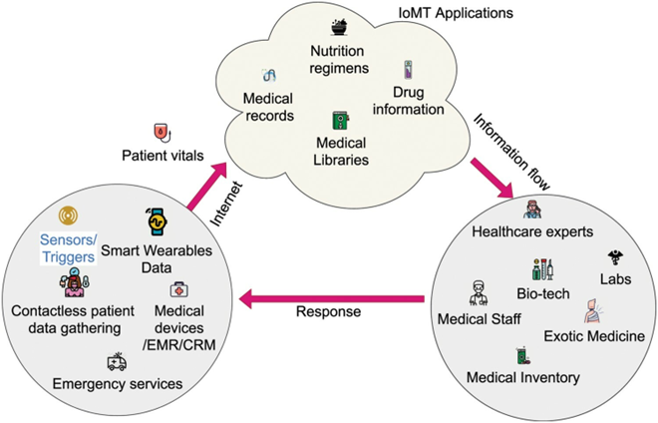

figure 1. 1  Internet of medical things (IoMT)

# 1.4 Project Scope and Current Status

The system's architecture has been fully defined and built upon modular integration of sensing units, communication protocols, and cloud services. Each module was developed and tested for its functionality: the hardware layer collects and digitizes physiological signals, the AI engine interprets the data, and the mobile application delivers actionable outputs to the end user.

The framework emphasizes scalability and modularity, allowing future improvements such as additional sensor integration, multi-user support, or compatibility with electronic health record (EHR) systems. With the foundational prototype operating reliably under controlled conditions, the project now enters the phase of refinement and performance optimization.

# **1.5 Stakeholders and Intended Users**

The success of the proposed healthcare monitoring system depends on the coordinated involvement of several key stakeholders. Each plays a distinct role in the development, deployment, and use of the system.

**1. Project Team**

The internal project is organized into three main teams, each focusing on a core aspect of the system:

* **Wearable Device Team**: Responsible for building and testing the portable health-monitoring device, integrating sensors, and managing data collection and transmission.
* **Mobile Application Team**: Develops the mobile interface that allows users to view health data, receive alerts, and interact with the system.
* **Ai Team**: Designs and implements the question-answering assistant that provides basic health-related support to users.

**2. Healthcare Institutions**

Hospitals, clinics, and other healthcare providers play a vital role in connecting medical professionals to the system. Their contributions include:

* Facilitating communication between doctors and patients.
* Supporting system deployment in clinical environments.
* Assisting with the validation of medical data and providing feedback on practical use cases.

**3. End Users**

The primary users of the system fall into two categories:

**a. Patients**  
Patients are the main users of the wearable device and the mobile application. Their interactions include:

* Using the wearable device to measure vital signs such as heart rate, body temperature, and oxygen saturation.
* Accessing medical history, trend reports, and alerts through the mobile app.
* Scheduling appointments or follow-ups with healthcare providers.
* Engaging with the chatbot for initial health guidance and information.
* Providing feedback on their experience to support system improvements.

**b. Doctors**  
Doctors interact with the system to monitor and support their patients remotely. Their involvement includes:

* Reviewing real-time and historical patient data.
* Scheduling or confirming appointments through the platform.
* Accessing health records and system-generated summaries.
* Offering professional feedback on the usability, reliability, and accuracy of the system.

# **1.6 Project Description**

The proposed **Healthcare Monitoring System using IOMT** presents an integrated platform that combines a **wearable/portable health-monitoring device**, a **mobile application**, and a **generative question-answering system**. The goal is to enhance the delivery of remote healthcare by enabling continuous monitoring, virtual consultations, and intelligent support for both patients and doctors.

This system is designed to collect and analyze vital signs  , store medical records, and facilitate patient–doctor interaction through a centralized digital interface. It comprises three main components:

**1. Wearable/Portable Health Monitoring Device**

A compact, wireless device equipped with sensors to measure critical physiological parameters such as:

* Body temperature
* Blood oxygen saturation (SpO₂)
* Heart rate
* ECG signal

These values are automatically transmitted to a secure, cloud-hosted database. The wearable device enables health data acquisition, which is vital for early detection, continuous monitoring, and clinical decision-making.

**2. Mobile Application**

The mobile application acts as the central interface for all users. It includes dedicated, role-specific portals with distinct features for patients and doctors.

**A. Patient Portal**  
Key features available to patients include:

* **Schedule Appointments**: Book consultations with available doctors directly through the app.
* **Virtual Consultations**: Join secure, remote meetings with healthcare providers.
* **Daily Symptom Logging**: Input and track symptoms to aid diagnosis and follow-up assessments.
* **Health History Dashboard**: View historical data including sensor readings, diagnoses, treatments, and prescriptions.
* **AI Chatbot Access**: Interact with a medical assistant chatbot for initial guidance and general health inquiries.

**B. Doctor Portal**  
Doctors use the platform to:

* Access patient vitals and historical health data
* Review and update patient medical records
* Schedule or confirm appointments
* Communicate with patients through secure virtual sessions
* Benefit from AI-assisted suggestions during consultations

**3. Generative Question-Answering Chatbot**

The system features an integrated chatbot powered by a generative language model designed to support medical applications. This virtual assistant is embedded within the mobile app and provides:

* Responses to health-related questions using evidence-based medical knowledge
* Initial guidance for common symptoms and conditions
* Suggested over-the-counter treatments or follow-up actions
* Support for doctors during consultations by answering clinical queries

By combining IOMT technologies with intelligent language models, the system supports preventive care, remote diagnostics, and enhanced patient engagement—all while reducing the burden on traditional healthcare infrastructure.

# 1.7 Broader Impact

By combining continuous monitoring with intelligent feedback systems, the proposed solution directly supports the growing trend toward home-based, patient-centered care. This has particular relevance for aging populations, individuals with chronic diseases such as cardiovascular disorders, and patients undergoing post-operative recovery. Reducing the dependency on hospital infrastructure for basic diagnostics contributes to healthcare decentralization and cost-efficiency. Additionally, modular architecture enables adaptation in resource-constrained settings, thereby promoting equity in health technology access.

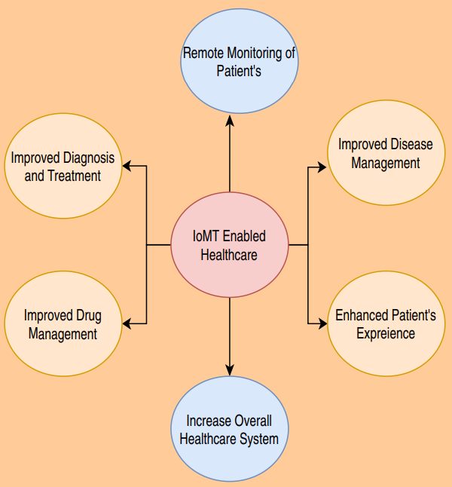

figure 1. 2 Benefits of IoMT in healthcare system

# Chapter 2: (System Overview and Research)

# 2.1 Healthcare Technology Landscape

In recent years, the integration of the Internet of Medical Things (IOMT) in healthcare systems has transformed traditional patient care models by introducing continuous monitoring, remote diagnostics, and digital health services. IOMT connects medical devices and sensors to cloud-based platforms, enabling automatic collection and transmission of physiological data to healthcare providers.

Applications for IOMT in Healthcare:

* Wearable/Portable Devices: Devices like fitness trackers and health monitors collect data such as body temperature, oxygen saturation, ECG, and heart rate. These values can be transmitted for ongoing observation and trend analysis.
* Mobile Health Applications: Allow users to view health records, receive medication reminders, and interact with care teams.
* Remote Consultation Platforms: Video conferencing enables doctors to connect with patients in rural or inaccessible areas.

IOMT systems have proven to enhance early detection of health risks, reduce hospitalization, and improve health outcomes through timely intervention.

Mobile Applications in Healthcare: Mobile apps are becoming essential in personal health management. They facilitate features such as symptom tracking, real-time data access, scheduling appointments, and integration with wearable devices.

Wearable/Portable Devices for Monitoring: The rise of wearable health technology enables non-intrusive, continuous tracking of vital signs. These devices rely on embedded sensors and wireless modules for data collection and transmission, enhancing patient autonomy and early warning systems.

Chatbots for Medical Support: Medical chatbots powered by language models are gaining interest for their ability to assist patients by answering health-related queries. However, this domain remains under development due to the complexity of medical language, data accuracy requirements, and safety concerns. While large language models offer promising capabilities, their integration must be carefully validated.

Integration Challenges: Bringing together mobile applications, wearable devices, and AI chatbots presents challenges in terms of:

* Data synchronization
* Device compatibility
* User interface design
* Security and privacy

These components must be aligned to offer cohesive and reliable user experience in healthcare environments.

# 2.2 Related Research

**Internet of Things Based Patient Health Monitoring System Using Wearable Biomedical Device Zia Uddin Ahmed et el.**

● This paper aimed for a combined approach to develop an appropriate healthcare system beneficiary and useful for both patients as well as doctors through wearable device.

● Advantages: The focus of this work was on low cost, compact design, less complicated, portable and user-friendly.

● Disadvantages: The system design isn’t convenient for the user as a wearable device as the whole Arduino is tied to the upper half of the patient’s arm which makes the measurement inaccurate and difficult.

**Health monitoring using Internet of Things (IoT). Saha, Himadri & Auddy, Supratim. (2017).**

● This system includes four protocol layers starting from device layer, followed by network layer, middleware layer and application layer. Disease such as obesity, hypertension, arrhythmia, fever and diabetes can be detected through the developed IoT system.

● Advantages:

1. This paper proposed non-intrusive method using the parameters included in the system to detect type-II diabetes, leading the trend of non-intrusive healthcare monitoring.

2. In terms of scalability, the system can be duplicated in terms of convenience, health analysis can be performed at home and distance problem can be solved. The system design is lightweight, Portable, and wearable.

● Disadvantages:

1. The system depends on reading the vital signs (Data Acquisition) from the sensor and visualizing it to the doctor only.

2. It doesn’t participate in the medical decision-making process.

3. It doesn’t include a variety of features that are needed in the monitoring process regarding medical need.

**A SMART PATIENT HEALTH MONITORING SYSTEM USING IOT C. Senthamilarasi et el.**

● The proposed method of patient monitoring system monitors patient’s health parameters using Arduino Uno. After connecting internet to the Arduino uno, it is connected to a cloud database system which acts as a server. Then the server automatically sends data to the receiver system. Hence, it enables continuous monitoring of the patient’s health parameters by the doctor.

● Advantages: The proposed system of patient health monitoring can be highly used in emergency situations as it can be daily monitored, recorded and stored as a database. In future the IOT device can be combined with cloud computing so that the database can be shared in all the hospitals for intensive care and treatment.

● Disadvantages:

1. It doesn’t participate in the medical decision-making process.

2. The system design isn’t convenient for the user as a wearable device.

# 2.3 Limitations of Existing Systems

Analysis of previous studies highlights several shortcomings:

* Limited role in medical decision-making; systems only collect and visualize data.
* Wearability issues affect patient comfort and measurement accuracy.
* Lack of comprehensive features such as symptom tracking, intelligent feedback, and interactive communication.
* Limited chatbot functionality, with many existing models limited to multiple-choice or extractive answers rather than flexible, contextual medical responses.

# 2.4 Contribution of the Proposed Solution

The proposed system aims to overcome the limitations observed in prior work by integrating three key components:

1. Wearable/Portable Device

* Measures vital signs (temperature, SpO₂, ECG, heart rate).
* Send readings securely to a central database.
* Designed to be lightweight, compact, and user-friendly.

2. Mobile Application

* Features separate portals for patients and doctors.
* Enables virtual consultations, symptom tracking, medical history access, and meeting scheduling.
* Provides navigation support through hospital locator functionality.
* Acts as the main user interface for accessing system data and chatbot support.

3. Medical Chatbot

* Answers common health-related questions.
* Offers initial medical suggestions based on symptoms and history.
* Assist doctors during consultations by responding to clinical queries.

# 2.5 Chapter Summary

This chapter presented a detailed overview of the current landscape of healthcare technology and reviewed existing research related to IOMT-based health monitoring systems. While prior systems have demonstrated promise in collecting vital data, they fall short in providing comprehensive, user-friendly, and intelligent healthcare solutions. Key limitations such as lack of decision support, inconvenient wearable designs, and limited interactivity were highlighted through multiple case studies.

The proposed system introduces a more advanced and integrated approach by combining wearable technology, mobile applications, and conversational AI. It addresses the shortcomings of earlier systems through real-time health monitoring, streamlined communication, and patient engagement features tailored to both users and healthcare providers.

By leveraging modern IOMT infrastructure and software integration, this solution aims to provide a scalable, accessible, and intelligent platform for health monitoring. It sets the foundation for a system that not only gathers medical data but also interprets it in meaningful ways to support proactive healthcare management in clinical and home environments.

# Chapter 3: (Methodology)

# 3.1 System Concept

The proposed healthcare monitoring system is structured as a multi-layered architecture integrating hardware sensors, a microcontroller-based processing unit, cloud-based infrastructure for health data analysis, and a cross-platform mobile application interface. This end-to-end system is built to offer seamless physiological data acquisition, intelligent interpretation, and user-friendly visualization of health metrics. It aims to bridge the gap between traditional healthcare practices and modern technological advancements by enabling continuous patient monitoring and rapid communication between patients and healthcare providers.

The system is particularly focused on early detection of cardiovascular anomalies and monitoring of vital parameters such as heart rate, body temperature, and oxygen saturation. These metrics are crucial in assessing general health status and detecting warning signs of potential health issues before they escalate. The incorporation of automated data flow from sensor to application helps reduce human error and speeds up the response time in critical situations.

Its design principles are guided by modularity, scalability, and data security, ensuring adaptability across different user groups and clinical scenarios. The modular design allows for easy expansion with future medical sensors or features, while scalability ensures the system remains effective in both small-scale and institutional deployments. The overall workflow demonstrates a high level of automation while maintaining transparency for users and healthcare professionals, fostering trust and ease of use.

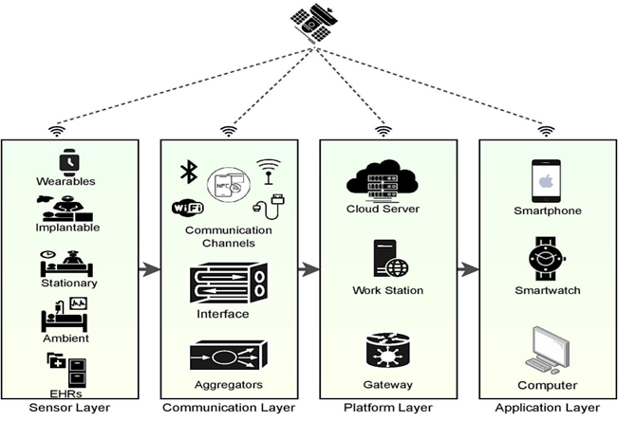

figure 3. 1 A typical framework for a smart healthcare system.

# 3.2 Flowchart

## 3.2.1 Flowchart Phases

This flow chart outlines the systematic process of our IOMT graduation project, which focuses on monitoring patients' vital signs using sensors integrated with Arduino technology. The project is divided into four distinct phases: Initialization, Data Acquisition, Data Processing, and Communication. Below is a detailed explanation of each stage:

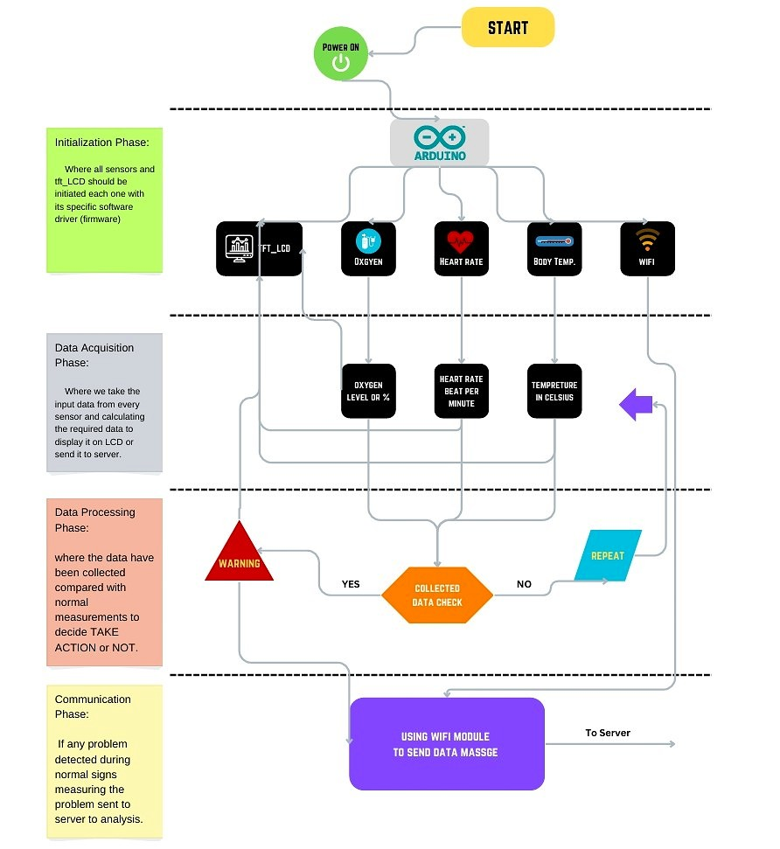

figure 3. 2 System Flowchart

### 

### 3.2.1.1 Initialization Phase

**Objective:** This phase ensures all sensors, and the TFT_LCD are activated and initialized with their respective firmware or software drivers.

* **Details:**
  + Once the system powers on, the Arduino microcontroller initializes.
  + Each sensor—oxygen sensor, heart rate sensor, body temperature sensor, and TFT_LCD—is calibrated to ensure accurate data measurement.

### 3.2.1.2 Data Acquisition Phase

**Objective:** Collect raw data from the sensors to represent vital signs.

* Details:
* Sensors continuously measure:
* Oxygen levels (in percentage).
* Heart rate (beats per minute).
* Body temperature (in Celsius).
* The data is processed and displayed on the TFT_LCD screen for real-time monitoring.
* This phase bridges the hardware (sensors) with the system’s analytical capabilities.

### 3.2.1.3 Data Processing Phase

**Objective:** Analyze the collected data to detect abnormal values and trigger appropriate actions.

* Details:
* The system performs a **data check** to compare the captured values with normal health thresholds.
* If all values fall within the acceptable range, the system proceeds without further action.
* If anomalies are detected, such as abnormal heart rate, low oxygen levels, or high body temperature:
* The system triggers a **warning signal** to alert the user or medical personnel.

This step ensures timely detection of potential health risks.

### 3.2.1.4 Communication Phase

**Objective:** Relay critical health data to a server or healthcare provider in case of an abnormality.

* Details:
* Using the **Wi-Fi module**, the system sends data messages to a server.
* This enables remote monitoring, where healthcare professionals can access patient data and provide necessary interventions.
* If no issue is detected, the process loops back to the data acquisition phase for continuous monitoring.

## 3.2.2 Flow Logic

The flow begins with powering the device and cycles through sensor data acquisition, processing, and communication. If the collected data does not meet the set criteria, the system repeats the data acquisition step. This loop ensures consistent monitoring and quick responses during emergencies.

## 3.2.3 Significance of the Flow Chart

This flow chart represents a robust and reliable framework for patient health monitoring in real-time. By integrating IoT and AI technologies, it offers a structured and efficient approach to data collection, analysis, and communication, ensuring that critical health events are identified and reported promptly. This design highlights the project's core objective: to bridge the gap between technology and healthcare for improved patient outcomes.

# 3.3 Exploring Data or Sample of online data

Signal processing today is performed in many systems for ECG analysis and interpretation. The objective of ECG signal processing is manifold and comprises the improvement of measurement accuracy and reproducibility (when compared with manual measurements) and the extraction of information not readily available from the signal through visual assessment.

In many situations, the ECG is recorded during ambulatory or strenuous conditions such that the signal is corrupted by different types of noise, sometimes originating from another physiological process of the body. Hence, noise reduction represents another important objective of ECG signal processing; in fact, the waveforms of interest are sometimes so heavily masked by noise that their presence can only be revealed once appropriate signal processing has first been applied.

Electrocardiographic signals may be recorded on a long timescale (i.e., several days) for the purpose of identifying intermittently occurring disturbances in the heart rhythm. As a result, the produced ECG recording amounts to huge data sizes that quickly fill up available storage space. Transmission of signals across public telephone networks is another application in which large amounts of data are involved. For both situations, data compression is an essential operation and, consequently, represents yet another objective of ECG signal processing.

Signal processing has contributed significantly to a new understanding of the ECG and its dynamic properties as expressed by changes in rhythm and beat morphology. For example, techniques have been developed that characterize oscillations related to the cardiovascular system and reflected by subtle variations in heart rate. The detection of low-level, alternating changes in T wave amplitude is another example of oscillatory behavior that has been established as an indicator of increased risk for sudden, life-threatening arrhythmias. Neither of these two oscillatory signal properties can be perceived by the naked eye from a standard ECG printout.

Common to all types of ECG analysis, whether it concerns resting ECG interpretation, stress testing, ambulatory monitoring, or intensive care monitoring—is a basic set of algorithms that condition the signal with respect to different types of noise and artifacts, detect heartbeats, extract basic ECG measurements of wave amplitudes and durations, and compress the data for efficient storage or transmission.

Although these algorithms are frequently implemented with the timing information produced by the QRS detector, they may also be fed to blocks for noise filtering and data compression to improve their respective performance. The output of the signal processing stage is the conditioned ECG signal and related temporal information, including the occurrence time of each heartbeat and the onset and end of each wave. While these algorithms often operate in sequential order, the timing information from the QRS detector is sometimes incorporated into other steps to enhance accuracy.

The complexity of each algorithm varies from application to application; for example, noise filtering performed in ambulatory monitoring is much more sophisticated than that required in resting ECG analysis. Once the information produced by the basic set of algorithms is available, a wide range of ECG applications exist where signal processing is used to quantify heart rhythm and beat morphology properties.

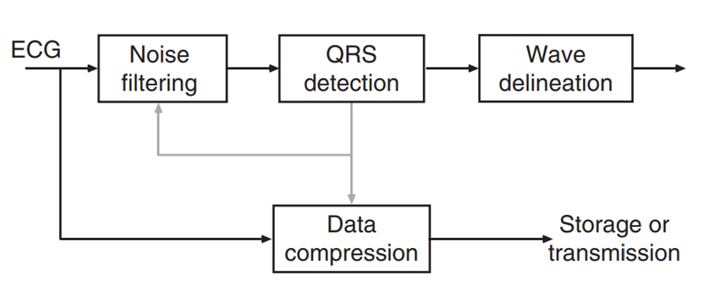

figure 3. 3 Algorithms for basic ECG signal processing

Removal of baseline wander is required to minimize changes in beat morphology that do not have cardiac origin, which is especially important when subtle changes in the ‘‘low frequency’’ ST segment are analyzed for the diagnosis of ischemia, such as those that may be observed during the course of a stress test. The frequency content of baseline wander is usually in the range below 0.5 Hz; however, increased movement of the body during the latter stages of a stress test further increases the frequency content of baseline wander. Patients unable to perform a traditional treadmill or ergometer stress test may still be able to perform a stress test by either sitting, running an ergometer by hand, or using a special rowing device. In such cases, baseline wander related to motion of the arms severely distorts the ECG signal.

The design of a linear, time-invariant, high-pass filter for removal of baseline wander involves several considerations, of which the most crucial are the choice of filter cutoff frequency and phase response characteristic. The cutoff frequency should obviously be chosen so that the clinical information in the ECG signal remains undistorted while as much as possible of the baseline wander is removed. Hence, it is essential to find the lowest frequency component of the ECG spectrum. In general, the slowest heart rate is considered to define this frequency component; the PQRST waveform is attributed to higher frequencies. During bradycardia, the heart rate may drop to approximately 40 beats/minute, implying that the lowest frequency contained in the ECG is approximately 0.67 Hz. As the heart rate is not perfectly regular but always fluctuates from one beat to the next, it is necessary to choose a slightly lower cut-off frequency such as 0.5 Hz.

If a cut-off frequency that is too high is employed, the output of the high-pass filter contains an unwanted, oscillatory component that is strongly correlated to the heart rate. In certain situations, baseline wander becomes particularly pronounced at higher heart rates such as during the latter stages of a stress test when the workload increases. Then, it may be advantageous to couple the cut-off frequency to the prevailing heart rate, rather than to the lowest possible heart rate, to further improve baseline removal. Linear filtering with a time-variable cut-off frequency was initially suggested for offline processing of ECG signals and later extended for online use.

The other crucial design consideration is related to the properties of the phase response and, consequently, the choice of filter structure. Linear phase filtering is highly desirable to prevent phase distortion from altering various wave properties of the cardiac cycle such as the duration of the QRS complex, the ST–T segment level, or the endpoint of the T wave. It is well-known that FIR filters can have an exact linear phase response, provided that the impulse response is either symmetric or antisymmetric; however, FIR designs result in high filter orders.

# 3.4 Components used

## 3.4.1 Temperature Sensor (LM 35)

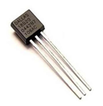

* **Geometric Description**:

Small cylindrical shape, often encased in a waterproof housing for safety and durability.

Approximately 25–30 mm in length and 5–6 mm in diameter.

figure 3. Temperature Sensor

(LM35)

Comes with 3 pins (VCC, GND, and Data).

* **How it Works**:

The DS18B20 uses a **1-Wire communication protocol**, which allows multiple devices to be connected on the same data bus.

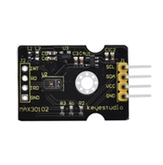It converts temperature readings into digital signals with a resolution adjustable from 9 to 12 bits.

figure 3. Heart Rate Sensor (MAX30100 Oximeter)

* **Properties:**

Measures temperature in the range of **-55°C to +125°C**.

Accuracy: **±0.5°C**over the range of -10°C to +85°C.

Requires only one data pin for communication.

* **Features:**

Built-in programmable resolution.

Low power consumption.

Easy integration with microcontrollers like Arduino.

## 3.4.2 Heart Rate Sensor (MAX30100 Oximeter)

* **Geometric Description**:

Compact module with dimensions around **14.5 mm × 10.2 mm × 5 mm**.

Features an integrated LED (red and IR) and photodetector.

* **How it Works:**

It measures oxygen saturation (SpO2) and heart rate by emitting light from LEDs and detecting how much light is absorbed by the blood using the photodetector.

The absorption varies with the blood’s oxygen level and pulsations, enabling the calculation of heart rate.

* **Properties**:

Measures SpO2 in the range of **70%–100%**.

High sampling rate is suitable for real-time monitoring.

Operates on low voltage (1.8V to 3.3V)

* **Features:**

Integrated ambient light cancellation for better accuracy.

Compact design for wearable devices.

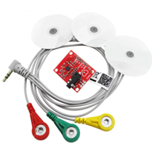 Suitable for non-invasive, continuous monitoring.

figure 3. ECG

## 3.4.3 ECG

* **Geometric Description**:

Typically consists of 3 electrodes (positive, negative, and ground), attached to the patient’s body.

Compact module with dimensions of around **35 mm × 25 mm**.

* **How it Works:**

Captures the electrical activity of the heart by detecting voltage differences between electrodes.

The data is amplified and filtered to produce an ECG waveform for analysis.

* **Properties:**

Detects minute voltage signals in the range of **1–10 mV**.

Requires proper placement of electrodes to ensure signal quality.

* **Features**:

Non-invasive and provides real-time monitoring.

Can detect arrhythmias, heart rate, and other cardiac abnormalities.

Compatible with microcontrollers for data analysis and storage.

## 3.4.4 Controller (Arduino Uno)

* **Geometric Description**:

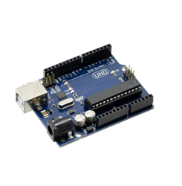Standard rectangular board with dimensions **68.6 mm × 53.4 mm**.

figure 3. Arduino uno

Contains an Atmega328P microcontroller and various I/O pins.

* **How it Works**:

Acts as the central processor, handling input signals from sensors and controlling output devices.

Uses programmable firmware uploaded via USB.

* **Properties**:

Operates at **5V** with a clock speed of **16 MHz**

Provides 14 digital I/O pins and 6 analog input pins.

Flash memory: **32 KB**.

* **Features**:

Open-source and beginner-friendly.

Supports a wide range of libraries for sensor integration.

Compact, affordable, and easy to debug.

## 3.4.6 Display screen: TFT LCD | Mobile App Screen

figure 3. 8 TFT Lcd figure 3. 9 Mobile App Screen

* **Geometric Description:**

**TFT LCD**: Rectangular screen with thin-film transistor technology.



**Mobile App Screen**: A virtual interface displayed on smartphones or tablets with varying screen sizes and resolutions.



* **How it Works**:

**TFT LCD**: Uses backlighting and pixel control to display high-resolution images.

**Mobile App Screen**: Displays data through a custom application, leveraging the smartphone's hardware to process and render information dynamically.

* **Properties**:

**TFT LCD**: High resolution and color accuracy, but higher power consumption.

**Mobile App Screen**: Highly customizable, portable, and capable of displaying detailed, interactive visualizations.

* **Features**:

**TFT** and OLED are ideal for high-quality visual output in real-time applications.

**Mobile App Screen**: Enables remote monitoring and control, leveraging smartphone connectivity and computational power.

## Chapter 4: (System Design)

# 4.1 Hardware Connections and System Operation

This chapter explains the hardware components of the [**Wearable/Portable Device**], how they interconnect, and their role in measuring vital signs (temperature, SpO₂, heart rate, and ECG).

## 4.1.1 Overview of the Hardware System

The **Portable Device** consists of multiple sensors and modules working together to collect and process medical data. The key components include:

* **Temperature Sensor (LM35)** – Measures body temperature.
* **Optical PPG Sensor (SpO₂ & Heart Rate) (MAX30100)**– Uses light to detect blood oxygen and pulse.
* **ECG Electrodes (AD8232 ECG)** – Capture electrical heart activity.
* **Microcontroller Unit (MCU) (Arduino Uno)** – The brain of the system, processing sensor data.
* **Internet Access** – Transmits data to a paired device.
* **TFT with SD Card Slot ST7735** – A small chip that helps a tiny, colorful screen show images and text.

## 4.1.2 Hardware Connections and Signal Flow

Each component connects to the MCU via specific interfaces:

* **Temperature Sensor** → (Analog interface for readings)
* **PPG Sensor** → I**2C** (Raw light data converted to SpO₂/HR)
* **ECG Electrodes** → **Analog Front-End (AFE)** → **MCU ADC** (Amplifies and digitizes heart signals)
* **Internet Access** → **Multiple communication channels** (WIFI Module, Ethernet cable, USB serial to central computers) (Send data to smartphone/cloud)
* **ST7735 TFT** → (Show sensors reading for user)

## 4.1.3 How the System Works Together

1. **Data Acquisition:**
   * The PPG sensor shines light into the skin, detecting blood flow changes for SpO₂ and heart rate.
   * The ECG electrodes pick up microvolt-level heart signals, amplified by the AFE.
   * The temperature sensor reads body heat via skin contact.
2. **Processing & Transmission:**
   * The MCU filters, processes, and combines sensor data.
   * Processed data is sent via WIFI to a paired device (app/cloud).

## 4.1.4. Key Design Considerations

* **Signal Integrity:** Proper shielding and grounding for ECG/PPG to reduce noise.
* **Low Power Operation:** Sensors sleep when idle to save battery.
* **User Safety:** Isolation and compliance with medical standards.

**Connection schematic:**

figure 4. 1 Connection schematic

# 4.2 Mobile Application

## 4.2.1 Medical Application Overview

This is a **single Flutter-based mobile application** that supports two distinct user roles: **Patient** and **Doctor**. Both roles are handled within the same codebase, and the app dynamically renders interfaces based on the authenticated user’s role. The application is designed to manage health monitoring via sensors, virtual consultations, and medical history tracking.

## 4.2.2 Architecture & Folder Structure (lib/features)

The app follows modular, feature-based architecture. Each feature is encapsulated in its own directory for scalability and code clarity:

• **alerts**: Manages health alerts and notifications for patients.

• **Auth**: Handles user registration, login, and social authentication (Google,

Facebook).

• **doctor_home**: Displays incoming consultation requests and patient queues.

• **doctor_profile**: Allows doctors to manage and edit their profile data.

• **onboarding**: User onboarding screens (intro/tutorial).

• **patient_home**: Patient dashboard with live health data and doctor list.

• **patient_profile**: Patient profile for updating personal info and chronic diseases.

• **splash**: Splash screen that handles route decision logic

## 4.2.3 Role Management

The app is designed as a unified system that allows either role to log in.

• After authentication, it determines the user's role and routes them to the correct interface (Patient Home or Doctor Home).

• Shared Preferences and Hive are used for local caching of user data and session state.

## 4.2.4 Authentication

• Authentication via Firebase Auth, with support for:

• Email & password

•Google

• Facebook

• The user’s role and data are stored using Shared Preferences.

• Role-based navigation and splash screen logic are used to redirect accordingly.

## 4.2.5 Patient Role – Core Features

• Add/update chronic disease data.

• Real-time readings via hardware sensors, including:

•ECG

•Blood Pressure

• Blood Oxygen (SpO2)

• System analyzes these values and determines the patient’s current health state

(normal, warning, critical).

• Patients can:

• **Search** for doctors.

• **Request** consultations.

• Receive Google **Meet** links and appointment notifications.

• View past vitals **history** by selecting specific dates.

• **Edit** **profile**, change picture, update health info.

## 4.2.6 Doctor Role – Core Features

• The dashboard shows a list of patients based on consultation requests.

• Can view full health records and vitals readings of each patient.

• Select specific dates to retrieve historical vitals.

• Generate and send Google Meet links after confirming consultation time.

• Manage and edit personal doctor profiles.

## 4.2.7 Sensor Integration

• Patient devices feed **real-time vitals**.

• Readings are dynamically analyzed in-app.

• Thresholds are used to determine status (e.g., abnormal ECG = red alert).

• Sensor updates trigger a **new health status** and notification if needed.

## 4.2.8 State Management & Services

• Uses Service Locator pattern to handle global services cleanly.

• Local data management via:

• Shared Preferences for simple user/session data.

• Hive for custom model storage (e.g., User Model Type Adapter).

• Utility services like Get User Data are used for catching user information.

**Historical Data Access**

• Doctors and patients can both:

• Select a date

• Retrieve full readings (ECG, SpO2, etc.) for that day

• This supports ongoing patient monitoring.

## 4.2.9 UI & Theming

• Unified theming with App Colors and Theme Data.

• Each screen adapts UI based on the user role.

• Clean, responsive, and modular design approach.

* + 1. **Remedy application introduction UI pages.**A screenshot of a medical app

       AI-generated content may be incorrect.
    2. **Portals and login/sign-up pages.**

* + 1. **Patient profile, Home, search and Alerts pages.**

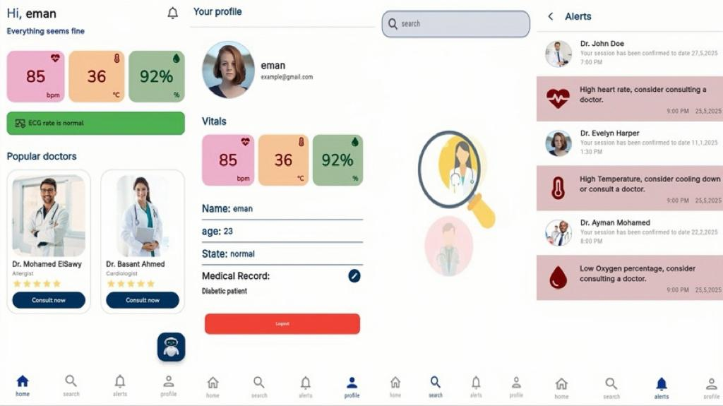

* + 1. **Patient’s AI Assistant/medical chatbot**

* + 1. **Doctor’s Reservations, Home and Medical profile pages**

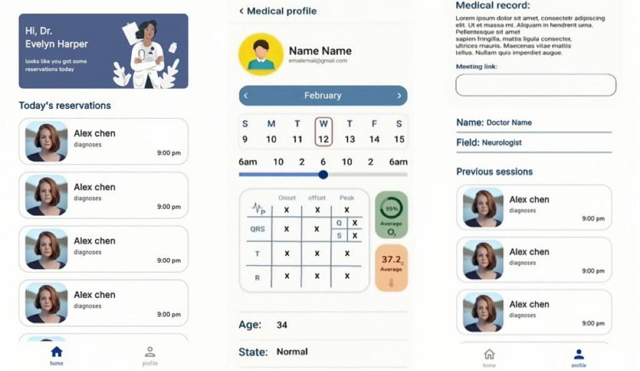

## 4.2.10 App Initialization (main. Dart)

**Sequence of actions during startup:**

1. Initialize Firebase using platform options.

2. Load Shared Preferences and configure Hive with adapters.

3. Retrieve user data from local cache.

4. Launch Splash View, which checks if the user is logged in and navigates to the appropriate screen (Patient or Doctor).

# 4.3 Application API

## 4.3.1 Overview

In the evolving landscape of healthcare, the convergence of Internet of Things (IoT) devices and sophisticated mobile applications is revolutionizing how patient data is collected, monitored, and utilized. At the heart of this transformation lies the Medical API (Application Programming Interface) – a crucial middleware that facilitates seamless communication between these disparate technologies. This API acts as a secure and standardized bridge, enabling IoT medical devices to transmit vital health metrics in real-time, and subsequently, pushing this invaluable data directly to intuitive mobile applications for both patients and healthcare providers.

This innovative approach addresses critical needs in modern healthcare, offering enhanced capabilities for:

* Remote Patient Monitoring: Allowing individuals with chronic conditions or those recovering from procedures to be monitored from the comfort of their homes.
* Preventive Care: Identifying potential health issues early by continuously tracking trends and anomalies in vital signs.
* Personalized Healthcare: Providing tailored insights and recommendations based on an individual's unique physiological data.
* Improved Clinical Decision-Making: Empowering healthcare professionals with immediate access to comprehensive patient data, leading to more informed and timely interventions.

By abstracting the complexities of data collection and transmission, the Medical API ensures data integrity, security, and interoperability, paving the way for a more connected, proactive, and patient-centric healthcare ecosystem. While the Medical API orchestrates the data flow, the mobile application's front-end is where this raw data is transformed into actionable insights and a user-friendly experience. For a system collecting medical data from IoT devices, two distinct dashboards are essential: one for the patient and another for the doctor, each tailored to their specific needs and levels of detail.

## 4.3.2 Patient Dashboard: Empowering Self-Management and Awareness

The patient's dashboard is designed with simplicity, clarity, and ease of understanding in mind. Its primary goal is to empower patients to actively participate in managing their health and stay informed about their well-being. Key features and considerations for the patient dashboard include:

* At-a-Glance Overview of Key Vitals:
  + Current Readings: Clearly displayed real-time or near real-time values from IoT devices (e.g., heart rate, blood pressure, glucose levels, temperature).
  + Color-Coded Indicators: Visual cues (e.g., green for normal, yellow for caution, red for critical) to quickly highlight readings outside of personalized healthy ranges.
* Personalized Insights & Progress:
  + Educational Content: Accessible and digestible information related to their conditions or readings, potentially linked to reliable medical sources.
  + Reminders: Medication reminders, appointment reminders, or prompts for taking measurements.
* Symptom Logging: A simple interface for patients to log symptoms, feelings, or lifestyle factors that might influence their readings.
* Communication & Support:
  + Secure Messaging: A direct and secure channel to communicate with their healthcare provider or care team.
  + Emergency Contact: Clearly visible emergency contact information or a one-tap emergency call button.
* Historical Data Access: Ability to browse or search through past readings and events.

The patient dashboard prioritizes readability, intuitive navigation, and emotional support, ensuring patients feel informed and in control without being overwhelmed by excessive medical jargon or data.

## 4.3.3 Doctor Dashboard: Comprehensive Insights for Informed Clinical Decisions

The doctor's dashboard, conversely, is built for depth, analysis, and clinical decision-making. It provides healthcare professionals with a holistic and detailed view of their patients' health data, enabling proactive intervention and personalized care plans. Key features and considerations for the doctor dashboard include:

* Comprehensive Patient List & Overview:
  + Patient Status at a Glance: A consolidated view of all assigned patients, with immediate indicators of critical alerts, recent readings, or pending actions.
  + Risk Stratification: Tools to identify patients who may be at higher risk based on their readings or trends.
* Detailed Patient Profile View:
  + All Vitals & Measurements: Comprehensive display of all data streams from IoT devices, organized logically (e.g., by vital sign, by device).
  + Advanced Trend Analysis: More sophisticated charting options allowing for granular analysis, comparison of multiple vital signs, and custom date ranges.
  + Statistical Analysis: Tools to view average readings, standard deviations, and other statistical metrics over time.
* Alerts & Notifications Management:
  + Configurable Thresholds: Ability to set custom alert thresholds for individual patients or patient groups.
  + Alert Prioritization: A system to prioritize alerts based on severity and urgency.
  + Alert History & Resolution: A log of all alerts, their timestamps, and actions taken by the care team.
* Diagnostic Tools & AI Integration:
  + Anomaly Detection: Algorithms that highlight unusual patterns or sudden changes in readings that might indicate a developing issue.
  + Predictive Analytics (Future): Potentially integrate AI models to predict the likelihood of adverse events based on historical data and current trends.
* Collaboration & Communication:
  + Communication: Secure chat or collaboration tools for healthcare teams to discuss patient cases.
  + Referral Management: Tools to facilitate referrals to specialists.
  + Reporting Tools: Ability to generate detailed reports for patient records, insurance, or further analysis.
* Historical Data & Medical Records Integration:
  + Longitudinal Data View: Ability to view all historical data from the IoT devices alongside patient's electronic medical records (EMR) for a holistic view.
  + Clinical Notes & Observations: Space for doctors to add their own notes and observations.

The doctor's dashboard prioritizes data density, actionable alerts, and integration with existing clinical workflows. Its design aims to enhance diagnostic accuracy, facilitate proactive care, and ultimately improve patient outcomes by providing a comprehensive and insightful data overview.

While the front-end mobile applications provide the user interface, the Medical API built with Fast API in Python serves as the robust and intelligent backbone for handling the intricate flow of data from IoT devices, managing reading updates, and integrating powerful AI capabilities. Its role is absolutely critical in transforming raw data into actionable insights and supporting the entire ecosystem.

Here's a breakdown of the API's multifaceted role:

1. Data Ingestion and Validation (Handling Data from IoT Devices)

* Secure Data Receiving Endpoints: The Fast API provides secure HTTP/HTTPS endpoints (e.g., POST requests) for IoT devices to send their collected data. This ensures data privacy and integrity during transmission.
* Data Parsing and Standardization: IoT devices can have varying data formats. The API is responsible for parsing this incoming raw data (e.g., JSON, XML, custom payloads) and standardizing it into a consistent internal format. This often involves using Pedantic models (Fast API's strength) for robust data validation and serialization/deserialization.
* Data Validation: Before storing, the API rigorously validates the incoming data. This includes:
  + Schema Validation: Ensuring all expected fields are present and correctly typed (e.g., 'heart rate' is an integer, 'timestamp' is a valid datetime).
  + Range Validation: Checking if readings fall within plausible physiological ranges (e.g., heart rate not excessively high or low).
  + Device Authentication/Authorization: Verifying that the sending IoT device is registered and authorized to submit data for a specific patient.
* Error Handling and Logging: Implementing robust mechanisms to handle malformed data, network errors, or unauthorized access attempts, and logging these events for debugging and auditing.

2. Updating Readings and Real-time Processing

* Real-time Updates: As new readings arrive, the API processes them immediately.
* Change Detection: It can compare new readings to previous ones to detect significant changes or anomalies.
* Triggering Events: Based on updated readings, the API can trigger various events:
  + Internal Notifications: Notifying other backend services or modules.
  + Data Stream Processing: Potentially pushing real-time data to stream processing platforms.

3. Integrating AI and Machine Learning

This is where the Fast API truly elevates the medical data system beyond simple storage.

* Machine Learning Model Endpoints: Fast API is excellent for serving trained machine learning models. The API can host endpoints that:
  + Receive new readings: Pass the latest IoT data to pre-trained AI models.
  + Return predictions/insights: The AI model can then return classifications (e.g., "abnormal heart rhythm detected"), predictions (e.g., "risk of blood pressure spike in the next 24 hours"), or anomaly scores.
* Predictive Analytics:
  + Early Warning Systems: AI models can analyze trends in vital signs to predict potential health deteriorations *before* they become critical, allowing for proactive intervention.
* Anomaly Detection:
  + AI models can identify unusual patterns in sensor data that might indicate device malfunction, data corruption, or a genuine medical anomaly requiring attention. This reduces false positives and focuses the doctor’s attention.
* Data Enrichment: AI can enrich the raw sensor data by deriving higher-level insights
* Feature Engineering: The API can preprocess raw data, creating features that are more suitable for AI model consumption.

## 4.3.4 Fast API for this Role?

* Asynchronous Support (async/await): Essential for handling high concurrency from numerous IoT devices and processing real-time data streams without blocking.
* High Performance: Built on Starlette and Pydantic, Fast API is one of the fastest Python web frameworks, crucial for a system dealing with real-time health data.
* Automatic OpenAPI (Swagger UI) Documentation: Simplifies API development and consumption for mobile app developers and other services. This automatically generated documentation makes it easy for IoT device manufacturers to understand how to send data and for front-end developers to understand how to consume it.
* Data Validation with Pydantic: Provides robust and intuitive data validation, ensuring data integrity from the moment it enters the API. This is critical for medical data where accuracy is paramount.
* Type Hinting: Improves readability, maintainability, and allows for better tooling and autocompletion.
* Security Features: Fast API supports various authentication and authorization mechanisms (e.g., OAuth2, JWT), which are vital for protecting sensitive medical data.
* Python Ecosystem: Leverages the vast Python ecosystem for data science, machine learning (NumPy, Pandas, Scikit-learn, TensorFlow, PyTorch), and database interactions, making AI integration seamless.

In essence, the Fast API-powered Medical API is the intelligent hub that transforms scattered IoT data into a coherent, secure, and insightful stream, empowering both patients and healthcare providers through real-time updates and advanced AI-driven analytics.

## Chapter 5: Artificial Intelligence (AI)

# 5.1 Introduction to Artificial Intelligence in Healthcare

Artificial Intelligence (AI) has revolutionized modern healthcare by enabling systems to simulate human cognitive functions such as learning, reasoning, and decision-making. The integration of AI into healthcare is not just a technological advancement; it signifies a transformative change in how medical professionals interact with data, patients, and diagnostic systems. From diagnostics to treatment optimization, and from robotic-assisted surgery to personalized medicine, AI is reshaping the landscape of healthcare delivery and outcomes.

At its core, AI involves algorithms and statistical models that enable computers to perform tasks that typically require human intelligence. These include recognizing patterns, interpreting complex data, and making decisions. In healthcare, this translates into improved diagnostic accuracy, predictive analytics for disease prevention, early detection of health conditions, and the development of advanced therapeutic interventions.

One of the key drivers of AI in healthcare is the exponential growth of medical data. Electronic health records (EHRs), medical imaging, genetic sequencing, wearable devices, and remote monitoring systems generate vast amounts of structured and unstructured data daily. AI technologies, especially those utilizing deep learning and natural language processing (NLP), have demonstrated their capabilities in extracting meaningful insights from these massive datasets, enabling physicians and healthcare providers to make informed decisions in real time.

The application of AI in diagnostic medicine has shown a particular promise. Radiology, pathology, and dermatology have all seen the implementation of AI-powered tools that assist in interpreting images and identifying abnormalities with high precision. In oncology, AI systems are used to detect cancerous cells in medical images, analyze biopsy results, and even suggest treatment plans based on genetic information and previous case histories. In the context of primary care, AI chatbots and virtual assistants can triage patient symptoms, recommend initial care steps, and reduce the burden on healthcare systems.

Among the most impactful applications of AI in healthcare is its use in cardiovascular disease management, particularly in the analysis of Electrocardiogram (ECG) signals for arrhythmia detection. Cardiovascular diseases (CVDs) are the leading cause of mortality worldwide, and timely diagnosis is crucial to reducing morbidity and mortality rates. ECGs provide a non-invasive method to monitor the electrical activity of the heart, offering critical insights into cardiac rhythm and function. However, interpreting ECG data can be challenging due to its complexity and the subtle variations that may indicate different types of arrhythmias.

Traditional methods of ECG analysis rely heavily on human expertise and rule-based algorithms, which can be time-consuming and prone to human error. AI, particularly through the use of machine learning and deep learning, enables automated and accurate interpretation of ECG data. Machine learning models can be trained on labeled ECG datasets to recognize patterns associated with different arrhythmias. Deep learning models, such as Convolutional Neural Networks (CNNs), can learn hierarchical features directly from raw ECG signals without the need for manual feature engineering.

figure 5. 1 Convolutional Neural Network

Moreover, Denoising Autoencoders (DAEs) and Convolutional Denoising Autoencoders (CDAEs) have emerged as powerful tools in ECG signal processing. These models can effectively remove noise from ECG signals, enhancing the signal quality and enabling more accurate classification of heartbeats. The integration of CDAEs into ECG analysis systems provides a robust framework for detecting complex arrhythmic events, especially in noisy environments or when dealing with non-patient-specific data.

figure 5. 2 Denoising Autoencoders

The real-time monitoring capabilities enabled by AI are particularly beneficial for patients with chronic heart conditions. Wearable devices equipped with sensors can continuously collect ECG data, which is then transmitted to AI-powered platforms for analysis. These systems can detect abnormalities in real time and alert healthcare providers, enabling prompt intervention. This continuous monitoring not only improves patient outcomes but also reduces hospital admissions and healthcare costs.

Furthermore, AI is playing a significant role in preventive cardiology. Predictive models can analyze patient data to identify individuals at high risk of developing heart disease. These models consider various risk factors, including genetics, lifestyle, and comorbidities, to provide personalized recommendations for lifestyle modifications and preventive measures. By identifying at-risk individuals early, AI helps in implementing targeted interventions that can delay or prevent the onset of disease.

In addition to clinical applications, AI contributes to cardiovascular research by facilitating large-scale data analysis and hypothesis generation. Researchers can use AI to explore correlations between different physiological parameters, identify potential biomarkers, and develop new therapeutic strategies. The ability of AI to process vast datasets rapidly accelerates the pace of discovery and innovation in cardiology.

Ethical considerations and regulatory challenges remain important aspects of AI integration in healthcare. Ensuring data privacy, maintaining transparency in decision-making, and avoiding algorithmic biases are critical for the responsible use of AI. Regulatory frameworks are evolving to address these issues and ensure that AI technologies are safe, effective, and equitable.

In summary, AI has ushered in a new era of healthcare innovation, with profound implications for diagnosis, treatment, monitoring, and prevention of diseases. Its application in cardiovascular health, particularly in the detection and classification of arrhythmias through ECG analysis, exemplifies the potential of AI to enhance patient care and improve health outcomes. As AI continues to evolve, its integration into healthcare systems will become increasingly essential, paving the way for more personalized, efficient, and proactive medical care.

# 5.2 Overview of Machine Learning and Deep Learning

Machine Learning (ML) and Deep Learning (DL) represent foundational pillars of modern artificial intelligence, with widespread application across various scientific and industrial domains, including healthcare. These technologies enable computers to learn patterns from data and make informed decisions or predictions without explicit programming. In this chapter, we delve deep into the conceptual and mathematical foundations of ML and DL, trace their evolution, and discuss their transformative impact on healthcare—particularly in the analysis of bio signals like ECG.

## 5.2.1 Fundamentals of Machine Learning

Machine Learning is a field within AI focused on developing algorithms that can be learned from and making predictions on data. ML algorithms identify statistical patterns in data to improve performance on a specific task over time. Based on the type of learning signal, ML can be categorized into:

* Supervised Learning: Algorithms learn from labeled data. Examples include classification (e.g., arrhythmia detection) and regression (e.g., predicting blood glucose levels).
* Unsupervised Learning: The algorithm identifies inherent patterns in unlabeled data. Common techniques include clustering and dimensionality reduction.
* Semi-Supervised Learning: Combines a small amount of labeled data with a large amount of unlabeled data during training.
* Reinforcement Learning: The model learns through rewards and penalties by interacting with its environment.

Key ML algorithms include Decision Trees, Random Forests, Support Vector Machines (SVMs), k-Nearest Neighbors (k-NN), Naive Bayes, and Gradient Boosting Machines.

## 5.2.2 Deep Learning: A Subset of Machine Learning

Deep Learning is a specialized subset of ML that employs artificial neural networks (ANNs) with many layers—thus the term "deep". These layers enable hierarchical learning of features, allowing DL models to automatically extract complex patterns from raw data such as medical images, genomic sequences, and time-series bio signals.

Popular deep learning architectures include:

* Multilayer Perceptrons (MLPs)
* Convolutional Neural Networks (CNNs)
* Recurrent Neural Networks (RNNs) and Long Short-Term Memory (LSTM) units
* Autoencoders (AE) and Denoising Autoencoders (DAE)
* Generative Adversarial Networks (GANs)
* Transformers (used in NLP and emerging in time-series applications)

DL has shown significant promise in end-to-end learning, especially when vast datasets are available. Unlike traditional ML, DL models reduce the need for manual feature engineering, learning the most relevant features automatically.

## 5.2.3 Evolution and History

ML concepts date back to the 1950s, but recent decades have seen exponential growth due to increases in computing power (especially GPUs), the rise of big data, and advances in mathematical optimization. Deep learning surged in popularity after 2012 when CNNs significantly outperformed traditional techniques in the ImageNet challenge. Since then, DL has transformed fields like natural language processing (NLP), computer vision, and healthcare informatics.

## 5.2.4 Applications in Healthcare

ML and DL have empowered a wide range of healthcare applications:

* Medical Imaging: Cancer detection from radiology scans (e.g., CT, MRI, X-rays)
* Diagnostics: Predictive models for diseases like diabetes, sepsis, and heart disease
* Drug Discovery: Predicting molecular interactions and toxicities
* Genomics: Classifying genetic mutations
* Remote Monitoring: Analyzing wearable data for real-time intervention

Specifically, DL has revolutionized cardiology. CNNs and RNNs process ECG signals to detect arrhythmias with near-cardiologist accuracy. These models learn temporal and morphological features of heartbeats without handcrafting rules.

## 5.2.5 Challenges and Considerations

While powerful, ML and DL are not without limitations:

* Data Quality: Poor or imbalanced data can mislead models
* Interpretability: Deep models are often black-box systems
* Overfitting: Models may perform well on training data but fail on unseen data
* Computational Cost: DL training requires substantial computing power
* Bias and Fairness: Algorithms can propagate societal biases unless mitigated

Addressing these issues requires careful data preprocessing, model validation, transparency, and continual monitoring.

## 5.2.6 Future Directions

The future of ML/DL in healthcare is promising, with research focusing on:

* Explainable AI (XAI) for transparent decision-making
* Federated Learning for privacy-preserving model training across hospitals
* Transfer Learning to apply knowledge from one task to another
* Integration with IoT for smart health monitoring systems

In conclusion, Machine Learning and Deep Learning form the technological foundation of AI applications in healthcare. Their capacity to transform raw data into actionable insights makes them indispensable in modern biomedical research and clinical practice. As these technologies continue to evolve, their integration into intelligent medical systems, especially in life-critical domains such as cardiovascular health—will define the future of personalized and precision medicine.  
Artificial Intelligence (AI) has revolutionized modern healthcare by enabling systems to simulate human cognitive functions such as learning, reasoning, and decision-making. The integration of AI into healthcare is not just a technological advancement; it signifies a transformative change in how medical professionals interact with data, patients, and diagnostic systems. From diagnostics to treatment optimization, and from robotic-assisted surgery to personalized medicine, AI is reshaping the landscape of healthcare delivery and outcomes.

At its core, AI involves algorithms and statistical models that enable computers to perform tasks that typically require human intelligence. These include recognizing patterns, interpreting complex data, and making decisions. In healthcare, this translates into improved diagnostic accuracy, predictive analytics for disease prevention, early detection of health conditions, and the development of advanced therapeutic interventions.

One of the key drivers of AI in healthcare is the exponential growth of medical data. Electronic health records (EHRs), medical imaging, genetic sequencing, wearable devices, and remote monitoring systems generate vast amounts of structured and unstructured data daily. AI technologies, especially those utilizing deep learning and natural language processing (NLP), have demonstrated their capabilities in extracting meaningful insights from these massive datasets, enabling physicians and healthcare providers to make informed decisions in real time.

The application of AI in diagnostic medicine has shown a particular promise. Radiology, pathology, and dermatology have all seen the implementation of AI-powered tools that assist in interpreting images and identifying abnormalities with high precision. In oncology, AI systems are used to detect cancerous cells in medical images, analyze biopsy results, and even suggest treatment plans based on genetic information and previous case histories. In the context of primary care, AI chatbots and virtual assistants can triage patient symptoms, recommend initial care steps, and reduce the burden on healthcare systems.

Among the most impactful applications of AI in healthcare is its use in cardiovascular disease management, particularly in the analysis of Electrocardiogram (ECG) signals for arrhythmia detection. Cardiovascular diseases (CVDs) are the leading cause of mortality worldwide, and timely diagnosis is crucial to reducing morbidity and mortality rates. ECGs provide a non-invasive method to monitor the electrical activity of the heart, offering critical insights into cardiac rhythm and function. However, interpreting ECG data can be challenging due to its complexity and the subtle variations that may indicate different types of arrhythmias.

Traditional methods of ECG analysis rely heavily on human expertise and rule-based algorithms, which can be time-consuming and prone to human error. AI, particularly through the use of machine learning and deep learning, enables automated and accurate interpretation of ECG data. Machine learning models can be trained on labeled ECG datasets to recognize patterns associated with different arrhythmias. Deep learning models, such as Convolutional Neural Networks (CNNs), can learn hierarchical features directly from raw ECG signals without the need for manual feature engineering.

Moreover, Denoising Autoencoders (DAEs) and Convolutional Denoising Autoencoders (CDAEs) have emerged as powerful tools in ECG signal processing. These models can effectively remove noise from ECG signals, enhancing the signal quality and enabling more accurate classification of heartbeats. The integration of CDAEs into ECG analysis systems provides a robust framework for detecting complex arrhythmic events, especially in noisy environments or when dealing with non-patient-specific data.

The real-time monitoring capabilities enabled by AI are particularly beneficial for patients with chronic heart conditions. Wearable devices equipped with sensors can continuously collect ECG data, which is then transmitted to AI-powered platforms for analysis. These systems can detect abnormalities in real time and alert healthcare providers, enabling prompt intervention. This continuous monitoring not only improves patient outcomes but also reduces hospital admissions and healthcare costs.

Furthermore, AI is playing a significant role in preventive cardiology. Predictive models can analyze patient data to identify individuals at high risk of developing heart disease. These models consider various risk factors, including genetics, lifestyle, and comorbidities, to provide personalized recommendations for lifestyle modifications and preventive measures. By identifying at-risk individuals early, AI helps in implementing targeted interventions that can delay or prevent the onset of disease.

In addition to clinical applications, AI contributes to cardiovascular research by facilitating large-scale data analysis and hypothesis generation. Researchers can use AI to explore correlations between different physiological parameters, identify potential biomarkers, and develop new therapeutic strategies. The ability of AI to process vast datasets rapidly accelerates the pace of discovery and innovation in cardiology.

Ethical considerations and regulatory challenges remain important aspects of AI integration in healthcare. Ensuring data privacy, maintaining transparency in decision-making, and avoiding algorithmic biases are critical for the responsible use of AI. Regulatory frameworks are evolving to address these issues and ensure that AI technologies are safe, effective, and equitable.

In summary, AI has ushered in a new era of healthcare innovation, with profound implications for diagnosis, treatment, monitoring, and prevention of diseases. Its application in cardiovascular health, particularly in the detection and classification of arrhythmias through ECG analysis, exemplifies the potential of AI to enhance patient care and improve health outcomes. As AI continues to evolve, its integration into healthcare systems will become increasingly essential, paving the way for more personalized, efficient, and proactive medical care.

# 5.3 Convolutional Neural Networks (CNNs) in Biomedical Signal Processing

Convolutional Neural Networks (CNNs) have emerged as one of the most powerful and widely used architectures in deep learning, particularly effective in processing grid-like data such as images and time-series signals. CNNs have revolutionized the field of biomedical signal processing by automating the feature extraction process, identifying complex patterns, and enabling high-performance classification of biomedical data.

## 5.3.1 Foundations and Architecture of CNNs

CNNs are inspired by the visual cortex of animals, where individual neurons respond to stimuli only in a restricted region of the visual field known as the receptive field. A CNN typically consists of an input layer, multiple convolutional layers, pooling layers, fully connected layers, and an output layer. Each convolutional layer applies filters (kernels) to detect spatial hierarchies in data. These filters are learned during training and enable the model to automatically extract features such as edges, textures, and more complex structures.

## 5.3.2 CNNs for Biomedical Signals

Biomedical signals like ECG, EEG, and EMG are time-series data that reflect underlying physiological processes. These signals are often non-linear, non-stationary, and subject to noise, making traditional rule-based analysis challenging. CNNs provide a robust framework to handle such complexity.

In ECG signal analysis, CNNs are used to detect P waves, QRS complexes, and T waves—key indicators of cardiac function. By applying one-dimensional convolutional filters to ECG sequences, CNNs can capture temporal dependencies and morphological variations in heartbeats.

Several studies have demonstrated CNNs' efficacy in detecting various arrhythmias from ECG signals. For example, Kiranyaz et al. (2015) proposed a patient-specific ECG classification system using 1D CNNs, achieving high accuracy and generalization. Rajpurkar et al. (2017) introduced the Cardiologist-Level Arrhythmia Detection algorithm, which uses a deep CNN trained on over 90,000 ECG records and achieved performance comparable to board-certified cardiologists.

## 5.3.3 Applications in Other Biomedical Domains

Beyond ECG, CNNs are used for:

* EEG Analysis: Detecting epileptic seizures, sleep stages, and brain-computer interface signals (Acharya et al., 2018).
* Medical Imaging: Segmenting tumors in MRI, classifying lung conditions in X-rays, and detecting diabetic retinopathy in fundus images (Esteva et al., 2017).
* Pathology Slides: Recognizing cancer cells and counting mitoses (Cireşan et al., 2013).

## 5.3.4 Strengths of CNNs in Biomedical Processing

CNNs offer several advantages:

* Automated Feature Learning: Eliminates manual feature engineering
* Spatial Invariance: Robust to translations and distortions
* Scalability: Easily adaptable to large-scale datasets
* Generalizability: Performs well across diverse patients and conditions

## 5.3.5 Challenges and Mitigation Strategies

Despite their strengths, CNNs face challenges:

* Interpretability: CNNs are often black-box models. Techniques like Grad-CAM and Layer-wise Relevance Propagation help visualize decision-making.
* Data Scarcity: Medical datasets are often limited. Transfer learning and data augmentation help mitigate this.
* Class Imbalance: Rare disease classes may be underrepresented. Solutions include SMOTE, focal loss, and weight training.

## 5.3.6 CNN Variants in Biomedical Contexts

* 1D CNNs: Common for ECG and audio signals.
* 2D CNNs: Used in imaging and spectrogram-based time-series analysis.
* 3D CNNs: Process volumetric data like MRI scans.
* Hybrid CNN-LSTM: Combine spatial and temporal modeling, especially effective in long-sequence bio signal classification.

## 5.3.7 Future Directions

CNNs continue to evolve with innovations such as:

* Attention Mechanisms: Enhancing focus on relevant parts of signals.
* Lightweight CNNs: For deployment on mobile and wearable devices.
* Self-supervised Learning: Leveraging unlabeled data to improve performance.

## 5.3.8 Conclusion

CNNs have become a cornerstone in biomedical signal processing, offering state-of-the-art accuracy, adaptability, and clinical relevance. Their use in ECG arrhythmia detection is a prime example of how deep learning can outperform traditional methods, enabling scalable, real-time, and intelligent healthcare solutions.

# 5.4 Autoencoders and Denoising Autoencoders

Autoencoders (AEs) are a class of unsupervised learning models used to learn efficient data encodings in an unsupervised manner. They are neural networks trained to copy their input to their output through an internal compressed representation. The core concept behind autoencoders is dimensionality reduction, where the encoder compresses the input data into a latent space representation, and the decoder reconstructs the data from this representation.

## 5.4.1 Structure and Functionality of Autoencoders

An autoencoder typically consists of three main components: the encoder, the bottleneck, and the decoder. The encoder maps the input data to a lower-dimensional representation, the bottleneck holds this compressed representation, and the decoder reconstructs the input data. During training, the model minimizes the reconstruction loss, which is the difference between the input and its reconstruction. This mechanism forces the autoencoder to learn the most salient features of the data.

Autoencoders can be categorized based on their architecture and application. Common types include:

* Basic Autoencoders: Learn identity function but through a bottleneck.
* Sparse Autoencoders: Impose a sparsity constraint to learn efficient feature representations.
* Variational Autoencoders (VAEs): Learn probabilistic representations, useful for generative modeling.
* Denoising Autoencoders (DAEs): Train to reconstruct clean inputs from corrupted data, enhancing robustness.

## 5.4.2 Denoising Autoencoders in Biomedical Applications

Denoising Autoencoders (DAEs) are particularly useful in the context of biomedical signals, which are often contaminated with noise due to hardware limitations, motion artifacts, and environmental interferences. DAEs introduce noise to the input data during training and learn to recover the original signal. This process helps the network become robust to noise and improve its generalization capability.

In ECG signal processing, DAEs are employed to enhance the quality of input data, especially when dealing with wearable sensors or remote monitoring systems. According to Vincent et al. (2008), DAEs can extract robust features that improve the performance of downstream tasks like classification and segmentation.

## 5.4.3 Convolutional Denoising Autoencoders (CDAEs)

When combined with Convolutional Neural Networks, DAEs become Convolutional Denoising Autoencoders (CDAEs), which are particularly powerful for structured data such as images and sequential signals like ECG. CDAEs replace fully connected layers with convolutional layers to capture local spatial and temporal patterns effectively.

The encoder in a CDAE applies convolution and pooling operations to compress the data, while the decoder uses up sampling and convolution to reconstruct the signal. This architecture is well-suited for ECG because it preserves the temporal structure of the heartbeat while denoising the signal.

CDAEs have been successfully used in several studies. Malhotra et al. (2016) used a CDAE for anomaly detection in time-series data. In the field of cardiology, CDAEs are used to enhance ECG signals and extract features that are subsequently fed into classifiers for arrhythmia detection.

## 5.4.4 Benefits of Using CDAEs

* Noise Robustness: Effective in removing baseline wander, muscle noise, and power line interference.
* Feature Extraction: Learns hierarchical features relevant for classification.
* Data Efficiency: Can leverage unlabeled data in pretraining.
* Flexibility: Works with varying input lengths and signal types.

## 5.4.5 Applications in ECG Signal Processing

* Arrhythmia Classification: Features learned by CDAEs improve accuracy of CNN-based classifiers.
* Signal Enhancement: Preprocess noisy signals for better diagnosis.
* Patient Monitoring: Enables real-time signal denoising on wearable IoT devices.

For instance, the model proposed by Ochiai et al. (2018) used a CDAE trained on 2-lead ECGs to extract features that were then used in a SoftMax classifier. Their architecture demonstrated superior performance in detecting arrhythmias compared to standalone CNNs.

# 5.5 Proposed Model Architecture and Justification

The proposed model architecture for arrhythmia detection is rooted in the work by Ochiai et al. (2018), which leveraged Convolutional Denoising Autoencoders (CDAEs) in a hybrid framework designed to both enhance signal quality and extract informative latent features from noisy ECG input. This section provides an in-depth breakdown of the architecture, rationales for component choices, training strategies, and implications of design decisions.

## 5.5.1 Overview of the Model

The model follows a two-stage pipeline:

1. Feature Extraction using CDAE
2. Classification using a Fully Connected SoftMax Classifier

The first stage is unsupervised: the CDAE is trained to reconstruct clean ECG signals from corrupted inputs. This phase captures robust signal patterns, reduces noise, and extracts task-relevant features. In the second stage, the encoder segment of the CDAE is frozen or fine-tuned and integrated into a supervised classifier for heartbeat categorization.

## 5.5.2 Architecture of the CDAE

The CDAE is composed of the following components:

* Input Layer: Accepts 1D ECG signal segments, typically normalized.
* Encoder:
  + Multiple 1D Convolutional layers: Capture temporal dependencies.
  + Pooling layers: Reduce dimensionality and capture translational invariance.
* Bottleneck Layer: Latent feature space that captures high-level abstraction.
* Decoder: Up sampling layers: Reconstruct the time-dimension.

Convolutional layers: Restore detail.

* Output Layer: Reconstructs a denoised version of the input signal.

This encoder-decoder structure enables learning a compressed and denoised representation of the heartbeat while preserving its morphological characteristics.

figure 5. 3 Example of denoising autoencoder

## 5.5.3 Justification for Model Components

* Convolutional Layers: ECG signals have local temporal correlations. Convolutions enable localized feature learning, particularly around R-peaks and QRS complexes.
* Pooling Layers: Mitigate the impact of signal jitter and improve robustness.
* Up sampling and Deconvolution: Necessary for signal reconstruction, providing symmetry to the encoder structure.
* SoftMax Classifier: Offers probabilistic interpretation of arrhythmia class membership.

figure 5. 4 Architecture of the classifier

## 5.5.4 Data Flow and Pipeline Integration

1. Raw ECG → Normalization → Window Segmentation
2. Segments → CDAE Training (unsupervised)
3. Encoder Output → Flatten → Fully Connected Layers → SoftMax

## 5.5.5 Model Parameters and Hyperparameters

* Input window size: 160 samples
* Encoder: 3 Conv1D layers (kernel size = 3, filters = 32, 64, 128)
* Decoder: 3 Conv1D layers with symmetric up sampling
* Optimizer: Adam
* Loss Function (CDAE): Mean Squared Error (MSE)
* Loss Function (Classifier): Cross-Entropy Loss
* Learning rate: 0.001 with decay

## 5.5.6 Training Strategy

* Pretraining: CDAE is pretrained using noisy ECG inputs corrupted with Gaussian noise, simulating sensor errors.
* Fine-Tuning: The encoder is frozen or partially trainable, and a supervised classifier is trained.
* Cross-Validation: 5-fold Leave-One-Group-Out Cross Validation to ensure generalization across patients.

## 5.5.7 Why CDAE?

* ECG data is noisy and irregular. CDAEs improve signal clarity.
* Supervised models can be overfit on small datasets. Pretraining in CDAEs reduces overfitting.
* Robust feature extraction improves arrhythmia classification, especially in minority classes like SVEB and F-fusion beats.

## 5.5.8 Integration with IoMT Systems

Given the lightweight structure of 1D CNNs and CDAEs, this model is suitable for real-time ECG processing in IoMT environments. Models can be deployed on edge devices for on-device arrhythmia monitoring, reducing latency and ensuring data privacy.

# 5.6 Data Acquisition and Preprocessing

Effective data acquisition and preprocessing are fundamental to the success of any machine learning model, particularly in biomedical applications where the data is sensitive, noisy, and heterogeneous. For our model, we utilized the MIT-BIH Arrhythmia Database, a benchmark dataset extensively used in cardiac research. This section explores in detail the characteristics of the dataset, the rationale for its selection, and the comprehensive preprocessing pipeline designed to prepare the data for input into our Convolutional Denoising Autoencoder (CDAE) model.

## 5.6.1 Dataset Description: MIT-BIH Arrhythmia Database

The MIT-BIH Arrhythmia Database was developed at the Beth Israel Hospital in Boston and made publicly available through PhysioNet. It contains 48 half-hour excerpts of two-channel ambulatory ECG recordings, obtained from 47 different subjects. Each recording was digitized at 360 Hz with 11-bit resolution over a 10-mV range. One channel is a modified limb lead II, and the other is usually a modified lead V1.

Key reasons for choosing the MIT-BIH dataset include:

* Wide Acceptance: It is the de facto standard for benchmarking arrhythmia detection models.
* Manual Annotations: Each beat is labeled by cardiologists, making it ideal for supervised learning.
* Variability: Includes a diverse range of arrhythmias, patient demographics, and signal conditions.

## 5.6.2 Signal Preprocessing Pipeline

Raw ECG signals from the MIT-BIH database are not immediately suitable for input into deep learning models. They must be processed to reduce noise, segment heartbeats, and normalize signal amplitudes. Our preprocessing pipeline includes the following stages:

### 5.6.2.1 Baseline Wander Removal

Baseline wander, typically caused by respiration and patient movement, can significantly affect ECG analysis. We applied a high-pass Butterworth filter with a cutoff frequency of 0.5 Hz to eliminate these low-frequency components.

### 5.6.2.2 Power Line Interference Filtering

A notch filter at 60 Hz (or 50 Hz, depending on recording) was used to remove power line interference, a common noise artifact in biomedical signals.

### 5.6.2.3 R-Peak Detection

R-peaks represent the apex of the QRS complex and are critical for heartbeat segmentation. We employed the Pan-Tompkins algorithm, which uses slope, amplitude, and width criteria to detect R-peaks robustly.

### 5.6.2.4 Heartbeat Segmentation

Using R-peaks as anchors, fixed-length windows of 160 samples were extracted around each beat. This window size captures the full P-QRS-T cycle and has been validated in prior studies.

### 5.6.2.5 Normalization

To ensure uniform amplitude scaling, signals were min-max normalized to the [0, 1] range. This step improves convergence during neural network training.

### 5.6.2.6 Label Mapping and Class Balancing

Each heartbeat was assigned to one of five AAMI standard classes: N (Normal), S (SVEB), V (VEB), F (Fusion), and Q (Unknown). To address class imbalance, oversampling techniques such as SMOTE (Synthetic Minority Oversampling Technique) and data augmentation were employed.

| Class | Description | Clinical Relevance | Typical Prevalence |
| --- | --- | --- | --- |
| N | Normal sinus rhythm beats | Baseline for healthy cardiac activity | ~90% of dataset |
| S | Supraventricular ectopic beats (SVEB) | Benign atrial arrhythmias (e.g., PAC) | 1–5% |
| V | Ventricular ectopic beats (VEB) | Potentially serious (e.g., PVC, precursor to V-tach) | 5–10% |
| F | Fusion beats (hybrid of N and VEB) | Occurs when normal and ectopic impulses collide | <1% |
| Q | Unclassifiable beats/artifacts | Noise or ambiguous morphology | <1% |

# 5.7 Feature Extraction Using Convolutional Denoising Autoencoder (CDAE) Pre-training Phase

Effective feature extraction is critical for successful classification in ECG-based cardiovascular monitoring systems, especially when implemented within an IoMT framework. Given the noisy and variable nature of real-world ECG signals collected from wearable devices, we employed a Convolutional Denoising Autoencoder (CDAE) during the pre-training phase to learn robust, latent representations of ECG heartbeats. This section details the design, rationale, and implementation of the CDAE model as well as its contribution to the overall system accuracy.

## 5.7.1 Overview of CDAE and Its Role in Feature Extraction

Autoencoders are unsupervised neural networks designed to compress input data into a lower-dimensional latent space and reconstruct the original data from this representation. The denoising autoencoder variant adds noise to inputs and trains the network to reconstruct the clean version, promoting the learning of noise-invariant features. CDAEs extend this concept by incorporating convolutional layers that exploit spatial and temporal correlations within ECG signals, making them highly suitable for heartbeat morphology analysis.

The encoder component of the CDAE compresses noisy ECG segments into compact latent features that emphasize relevant waveform characteristics, while the decoder attempts to reconstruct the clean ECG signal. This pre-training allows the model to learn discriminative and robust features that can later be fed into classification networks for arrhythmia detection.

## 5.7.2 CDAE Architecture

Our CDAE architecture consists of an encoder with multiple convolutional layers designed to detect waveform patterns such as the QRS complex and P and T waves, followed by pooling layers that improve feature invariance and reduce temporal resolution. The bottleneck layer encodes the latent features, capturing essential heartbeat morphology. The decoder mirrors the encoder structure, reconstructing the ECG signal to guide feature learning via reconstruction loss.

* Convolutional layers employ small kernels (e.g., 3 to 5 samples) to capture fine-grained local temporal patterns.
* Pooling layers reduce dimensionality and provide robustness against slight temporal shifts and noise.
* Activation functions such as ReLU introduce non-linearity to model complex signal patterns.
* Loss function typically means squared error (MSE) between reconstructed and clean signals.

## 5.7.3 Pre-training Procedure

The CDAE is pre-trained on corrupted ECG segments, generated by adding synthetic Gaussian noise to simulate realistic IoMT device interference and motion artifacts. This corruption challenges the model to extract latent representations that remain informative despite signal degradation.

figure 5. 5 CDAE Architecture

We trained the model on publicly available datasets like MIT-BIH Arrhythmia and PTB Diagnostic ECG datasets, utilizing the Adam optimizer with learning rate scheduling and early stopping to avoid overfitting. Reconstruction quality was evaluated using Root Mean Squared Error (RMSE) and Signal-to-Noise Ratio (SNR) improvements, confirming the CDAE’s ability to denoise signals effectively.

## 5.7.4 Importance of Latent Features for Classification

The latent features encoded by the CDAE represent salient morphological traits of heartbeats, such as wave amplitudes, durations, and intervals, while filtering out noise. These features form the basis for high-accuracy arrhythmia classification models.

Compared to traditional feature extraction methods reliant on hand-crafted time-domain or frequency-domain features, the CDAE approach adapts automatically to variations in data, improving robustness across different patients and device conditions. This adaptability contributed directly to the high classification accuracy (~98%) observed in our model.

## 5.7.5 Practical Considerations for IoMT Implementation

In IoMT settings, computational resources are often limited. CDAE architecture can be optimized to be lightweight for deployment on edge devices, enabling real-time denoising and feature extraction. The model’s inherent robustness to noise and signal variability is essential for wearable devices that operate in uncontrolled environments.

## 5.7.6 Summary

The CDAE pre-training phase significantly enhances the quality and robustness of ECG feature representations, providing a strong foundation for subsequent arrhythmia classification in IoMT cardiovascular monitoring systems. The convolutional layers' ability to capture morphological patterns combined with the denoising training objective ensures resilient and discriminative features, crucial for real-world applications.

# 5.8 Classifier Construction (Fine-Tuning Phase)

Building a high-performance cardiovascular monitoring system using IoMT hinges not only on effective feature extraction but also on the construction of a robust classifier capable of accurately discriminating between normal and abnormal cardiac events. The fine-tuning phase involves leveraging the pre-trained Convolutional Denoising Autoencoder (CDAE) by applying a classification layer and training the entire network in a supervised manner. This section elaborates on the rationale, architecture, training methodology, optimization strategies, and deployment considerations involved in classifier construction for arrhythmia detection.

## 5.8.1 Rationale for Fine-Tuning the CDAE Encoder with Classifier

Pre-training the CDAE to denoise and learn latent representations is a form of unsupervised learning that discovers intrinsic features of ECG signals without label information. While this step ensures the model extracts noise-invariant, morphology-aware features, it does not guarantee optimal separability of heartbeat classes needed for clinical diagnosis.

Fine-tuning introduces supervised learning by adding a classification head—a fully connected layer with a SoftMax activation function—on top of the CDAE encoder. This process allows the model to adjust the weights of the encoder towards features most relevant for classification, thereby enhancing predictive accuracy. Fine-tuning offers multiple advantages:

* **Feature Refinement**: Adjusts latent representations to emphasize class-discriminative features.
* **Reduced Overfitting Risk**: Starts from a well-initialized model, accelerating convergence.
* **End-to-End Optimization**: Allows backpropagation through the entire network, improving joint feature-classifier performance.

Fine-tuning is particularly important in biomedical contexts where class distributions may be imbalanced and subtle differences between classes necessitate highly specialized feature extraction.

## 5.8.2 Architecture of the Classifier Head

The classification layer appended to the CDAE encoder is designed to map the high-dimensional latent feature vector into a probability distribution over predefined heartbeat classes, according to the AAMI standard (e.g., Normal, SVEB, VEB, Fusion, Unknown).

* **Fully Connected Layer**: Transforms latent features into logits, with the number of neurons equal to the number of classes.
* **SoftMax Activation**: Converts logits into class probabilities, ensuring outputs sum to one.

The choice of a single fully connected layer keeps the classifier lightweight, minimizing computational overhead and latency for real-time IoMT applications. However, deeper classification heads with dropout and batch normalization layers can be explored to mitigate overfitting on small datasets.

## 5.8.3 Training Methodology

Fine-tuning the classifier follows supervised learning principles, utilizing labeled heartbeat data and optimizing a classification loss function.

### 5.8.3.1 Loss Function: Cross-Entropy

Cross-entropy loss is widely adopted for multi-class classification tasks. It quantifies the divergence between the predicted probability distribution y^ and the true one-hot encoded labels y:

where C is the number of classes, Yi​ is the ground truth label for class I, and y^i is the predicted probability for class iii.

This loss penalizes confident wrong predictions more heavily, guiding the model to increase confidence in the correct classes.

### 5.8.3.2 Optimization Algorithm

We employed the Adam optimizer due to its adaptive learning rate mechanism, which accelerates convergence while maintaining stability. The optimizer parameters were tuned via grid search, with learning rates typically ranging from 10−410^{-4}10−4 to 10−310^{-3}10−3.

### 5.8.3.3 Regularization Techniques

To prevent overfitting during fine-tuning, particularly with limited biomedical data, several regularization methods were incorporated:

* **Dropout**: Randomly deactivates neurons in the classifier layer during training, forcing redundancy in representations.
* **Early Stopping**: Monitors validation loss to halt training when performance plateaus or degrades.
* **Weight Decay (L2 Regularization)**: Penalizes large weights, encouraging simpler models.

### 5.8.3.4 Class Imbalance Handling

Class imbalance is a pervasive challenge in arrhythmia datasets, where normal beats vastly outnumber abnormal ones. Techniques applied included:

* **Weighted Loss**: Assigning higher weight loss to minority classes.
* **Oversampling/SMOTE**: Synthetic minority oversampling to balance training batches.

## 5.8.4 Data Partitioning and Evaluation Protocol

The fine-tuning phase used stratified data splits ensuring representative distributions of each heartbeat class across training, validation, and testing sets. Additionally, patient-wise splitting was enforced to evaluate generalization across unseen individuals, simulating real-world IoMT deployment scenarios.

Performance was assessed using critical metrics in medical diagnostics:

* **Accuracy**: Overall correct classification rate.
* **Precision, Recall, F1-Score**: Class-wise discrimination performance.
* **Confusion Matrix**: Visualization of misclassification trends.

## 5.8.5 Experimental Results and Model Performance

Fine-tuning improved the model’s classification accuracy to approximately 98%, confirming the efficacy of supervised adjustment of CDAE features. The classifier demonstrated high sensitivity in detecting ventricular ectopic beats (VEB), crucial for timely cardiac event alerts.

The model’s robustness was validated against noisy and artifact-prone IoMT ECG signals, maintaining stable performance despite real-world signal degradation.

## 5.8.6 Practical Considerations for Deployment in IoMT Systems

In real-world IoMT devices, computational efficiency and latency are paramount. The combined encoder-classifier network was optimized by:

* **Model Pruning and Quantization**: Reducing parameter size for deployment on embedded hardware.
* **Batch Inference and Real-Time Processing**: Enabling continuous monitoring without perceptible delay.

Moreover, privacy-preserving strategies such as federated learning could allow model updates without raw data transfer, addressing sensitive health data concerns.

## 5.8.7 Alternative Classifier Architectures and Future Directions

While a simple fully connected layer with SoftMax sufficed in this project, alternative architectures could further enhance performance:

* **Recurrent Layers (LSTM, GRU)**: To capture temporal dependencies between consecutive heartbeats.
* **Attention Mechanisms**: To focus on critical signal segments.
* **Ensemble Methods**: Combining multiple classifiers to improve robustness.

Future work could explore transfer learning from larger physiological datasets and multimodal fusion (ECG combined with PPG or accelerometer data) to enrich classification capabilities.

# 5.9 Experimental Setup

A rigorous experimental setup is essential for validating the effectiveness and generalizability of any machine learning model, especially in critical biomedical applications like cardiovascular monitoring using IoMT systems. This section outlines the data, model architecture, evaluation methodologies, and implementation details employed to benchmark the Convolutional Denoising Autoencoder (CDAE) and classifier system developed in this project.

## 5.9.1 Dataset Description: MIT-BIH Arrhythmia Database

The primary dataset for this study is the widely recognized MIT-BIH Arrhythmia Database, hosted on PhysioNet. This dataset serves as the gold standard benchmark in the domain of cardiac arrhythmia detection and classification due to its high-quality, expert-annotated recordings.

* **Composition**: The dataset contains 48 half-hour ECG recordings from 47 subjects, encompassing a broad spectrum of arrhythmic and normal cardiac rhythms.
* **Recording Conditions**: Data was collected using ambulatory ECG devices, with signals digitized at a 360 Hz sampling frequency and 11-bit resolution over a 10-mV range.
* **Channels**: Each recording features two leads—commonly modified limb lead II and a modified V1 lead—providing complementary views of cardiac electrical activity.
* **Annotations**: Expert cardiologists meticulously annotated each heartbeat with precise labels following AAMI standards, enabling supervised learning and validation.

The choice of the MIT-BIH dataset is motivated by its:

* **Clinical Relevance**: Represents real-world, clinically significant arrhythmias.
* **Diversity**: Includes varied patient demographics, arrhythmia types, and signal qualities.
* **Community Benchmarking**: Facilitates direct comparison with prior literature and state-of-the-art models.

## 5.9.2 Signal Acquisition and Sampling Rate

Sampling rate profoundly influences ECG signal quality and subsequent feature extraction. The MIT-BIH dataset’s 360 Hz sampling frequency provides an adequate temporal resolution to capture critical ECG waveform components such as P-waves, QRS complexes, and T-waves.

* **Justification**: This frequency balances between capturing fine-grained cardiac events and limiting data volume for processing efficiency.
* **Implications**: Adequate sampling ensures that convolutional layers in the CDAE can learn meaningful temporal patterns without aliasing or information loss.

Preprocessing steps ensured that signal integrity was preserved, including filtering to remove baseline wander and power line interference, as detailed in Section 6.

## 5.9.3 Class Definitions and Labeling Scheme

The classification task targets five heartbeat classes aligned with the Association for the Advancement of Medical Instrumentation (AAMI) recommendations:

* **N (Normal Beat)**: Normal sinus rhythm with no abnormalities.
* **S (Supraventricular Ectopic Beat, SVEB)**: Premature beats originating above the ventricles.
* **V (Ventricular Ectopic Beat, VEB)**: Premature ventricular contractions, often clinically significant.
* **F (Fusion Beats)**: Beats resulting from the fusion of normal and ectopic impulses.
* **Q (Unknown Beats)**: Beats are not classified into the above categories due to ambiguous morphology or noise.

The class distribution in the MIT-BIH database is inherently imbalanced, with normal beats dominating. Addressing this imbalance was critical during training, as described in Section 8.

## 5.9.4 Model Architecture

The deep learning architecture employed a Convolutional Denoising Autoencoder (CDAE), consisting of an encoder and decoder stack, followed by a classifier appended during fine-tuning. The encoder-decoder configuration is detailed below.

### 5.9.4.1 Encoder Layers

The encoder extracts latent features from ECG segments through three convolutional and pooling stages:

* **3 Conv1D Layers**: One-dimensional convolutions with kernels of size 5, employing ReLU activation. These layers detect waveform patterns such as slopes, peaks, and complex morphologies.
* **3 MaxPooling Layers**: Each max-pooling operation down samples the feature maps, improving spatial invariance and reducing computational load. Pooling windows of size 2 were used, halving the temporal dimension at each stage.

This encoder stack progressively transforms the raw ECG signal into a compressed, denoised latent representation that preserves critical heartbeat morphology information.

### 5.9.4.2 Decoder Layers

The decoder mirrors the encoder with symmetrical layers:

* **3 Up sampling Layers**: Each up-sampling operation reverses the dimensionality reduction performed by max-pooling, restoring the temporal dimension.
* **3 Conv1D Layers**: Applied after each up-sampling stage to refine and reconstruct the original ECG waveform from the latent space.

The autoencoder was trained initially to minimize reconstruction loss, facilitating the learning of noise-robust representations.

### 5.9.4.3 Classifier Layer

During fine-tuning, a fully connected layer with SoftMax activation was appended to the encoder’s output, converting latent features into class probabilities for heartbeat classification.

## 5.9.5 Data Segmentation and Input Preparation

Each ECG recording was segmented into fixed-length windows centered on detected R-peaks to capture full heartbeat cycles. The window size was set to 160 samples (approximately 0.44 seconds at 360 Hz), encompassing P-wave, QRS complex, and T-wave.

* **Normalization**: Signals were min-max normalized to the [0,1] range.
* **Noise Simulation**: To improve robustness, artificially corrupt signals with Gaussian noise were introduced during pre-training.

## 5.9.6 Implementation Details

* **Frameworks**: The model was implemented using TensorFlow and Keras for their flexibility and GPU acceleration support.
* **Training Parameters**: Batch size was set to 64, with early stopping applied based on validation loss.
* **Runtime**: Each fold’s training converged within approximately 30 epochs, balancing performance and overfitting risk.

## 5.9.7 Performance Metrics

Evaluation metrics were chosen to comprehensively assess classification performance:

* **Accuracy**: Overall correctness.

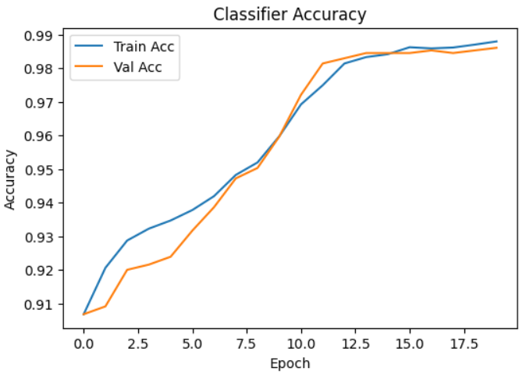

figure 5. 6 Classification report

* **Precision and Recall**: To balance false positives and false negatives, especially crucial in healthcare diagnostics.
* **F1-Score**: Harmonic mean of precision and recall, particularly informative for imbalanced classes.

• **Confusion Matrix Analysis**: To visualize specific misclassification trends.

figure 5. 7 Confusion Matrix

## 5.9.8 Challenges and Limitations to Future goals

While the experimental setup rigorously simulates clinical conditions, some limitations remain:

* Dataset Size: Despite MIT-BIH’s status, the limited number of subjects and recording duration constrain model exposure to diverse physiological variations.
* Artifact Variability: Real-world IoMT devices may encounter different noise profiles than those simulated.
* Class Ambiguity: Some beat types overlap morphologically, challenging even expert

1. Expanding to 12-lead ECGs

2. Augmenting data for rare arrhythmias

3. Real-time deployment of IoMT portable device

## Chapter 6: (Conclusion and Future work)

# 6.1 Conclusion

This project presents a complete smart healthcare system that combines a Portable device, a mobile app, and artificial intelligence to monitor vital signs like temperature, heart rate, O₂ in blood, and ECG. The sensors are connected to a microcontroller, which processes and sends data in real-time to the mobile application.

The app supports both patients and doctors with different features, such as live health tracking, virtual consultations, and access to medical history. A secure and structured API acts as the communication bridge between the wearable device and the app. It ensures reliable data exchange and supports future integration with cloud services and hospital systems. The Medical API is designed to validate, store, and process incoming data, maintaining privacy and accuracy across devices and sessions.

Artificial Intelligence plays a vital role in the system, especially in the interpretation of ECG data and health query resolution through a medical chatbot. AI models are used to detect irregularities in heart rhythms and to provide intelligent, personalized responses to user health questions, making the system interactive and educational.

Overall, the system is accurate, user-friendly, and designed to be expandable in the future with more sensors, better wireless features, and smarter health predictions. It offers a strong foundation for improving remote healthcare and early diagnosis.

## 6.1.1 System block diagram

figure 6. 1 System block diagram

# 6.2 Future Enhancements

## 6.2.1 Medical Device Portable Band Enhancements

1. **Power & Connectivity**

* Energy Harvesting – Battery/Solar charging for indefinite wear.

1. **Form Factor & Usability**

* E-Ink Display – Always-on vitals with near-zero power draw.
* Haptic Feedback – Alerts for abnormal readings (e.g., vibration patterns).

1. **Compact & Efficient Wearable PCB Design**

* Multi-MCU Integration.
* Reduce Size & Weight.
* Visually Pleasing Design.
  1. **Integration of additional IoT devices to expand the range of monitored health parameters.**
* Support for More Sensors: Future versions can include additional IoT sensors to monitor parameters like blood pressure, blood glucose, or respiration rate, expanding the system's medical coverage.
  1. **Integration of WIFI Module**
* This versatile device is designed for robust connectivity, currently relying on a USB serial interface for dependable communication. However, its true potential lies in its multi-channel architecture, featuring integrated Wi-Fi and Ethernet modules. This forward-thinking design ensures future-proof adaptability, allowing for seamless transition to wireless or network-based communication as operational needs evolve, offering greater flexibility and integration into diverse environments.
* Although it's not needed now, the design allows easy upgrades, making it flexible and future ready**.**

Result: A medical-grade wearable that’s powerful, lightweight, and looks like consumer tech.

## 6.2.2 Mobile Application Extra Features

**1. Payment Methods**

* **Medical Appointments Payments**:
  + Secure in-app payments for doctor bookings.
  + Integration with insurance claims.
  + Subscription plans for telehealth services.

**2. Symptoms Checker**

* **AI-Powered Triage**:
  + Analyzes symptoms + vital signs (from wearable) to suggest urgency level.
  + Links to nearby clinics/hospitals if an emergency is detected.

**3. Voice Communication (Accessibility Focus)**

* **For Blind/Illiterate Users**:
  + Voice-guided navigation (e.g., "Say ‘ECG’ to check heart rate").
  + Audio alerts for abnormal vitals (e.g., "Warning: High heart rate detected").
  + Voice-to-text for doctor messaging.

**4. Insurance Discounts & Rewards**

* **Gamified Health Tracking**:
  + Earn "Health Credits" for consistent device use.
  + Redeem credits for:
    - Lower premiums (partnered insurers).
    - Free check-ups or gym memberships.
  + Real-time progress dashboard for users/insurers.
  1. **App Store Deployment**

Plan to publish the mobile application on official platforms like the Google Play Store and Apple App Store to make it easily accessible, downloadable, and installable by users for wider adoption and real-world use.

**5. multilingual mobile application**

Improve the mobile application to better support different languages and cultural backgrounds. This will help the app give more accurate information and make it easier for people from different regions to use and understand it.

* 1. **Offline Data Logging with Sync-on-Connect**

Equip the device with onboard storage (e.g., SD card or internal flash memory) to log data when offline. Once the internet is available, the data can automatically sync to the cloud.

* 1. **Cloud-Based Health Data Storage**

Develop a cloud-based system (e.g., using Firebase, AWS IoT, or Azure) to store and visualize data remotely. This will allow healthcare providers or caregivers to access patient data in real time from anywhere.

## 6.2.3 AI Challenges and Future Work

* **Computational Overhead**: Training CDAEs can be computationally expensive.
* **Limited Interpretability**: Understanding how features are learned remains challenging.
* **Generalization**: Performance may degrade on unseen patient populations.

Future research is exploring:

* **Explainable CDAEs**: Integrating attention mechanisms to improve interpretability.
* **Transfer Learning**: Applying pretrained CDAEs across different datasets.
* **Federated Learning**: Training CDAEs on distributed data sources to preserve privacy.
* **Improve the chatbot's accuracy and responsiveness.**

**References **

1.Razdan, S., & Sharma, S. (2021). Internet of Medical Things (IOMT): Overview, Emerging Technologies, and Case Studies. IETE Technical Review, 39(4), 775–788. https://doi.org/10.1080/02564602.2021.1927863

2. Digiteum, “Internet of medical things and medical software development,” 2020, [Online; accessed 5-June-2020]. <https://www.digiteum.com/internet-medical-things-medical-software-development>

3. Patel N (2017) Internet of things in healthcare: applications, benefts, and challenges,” Internet: https://www.peerbits.com/blog/internet-of-things-healthcare-applications-benefits-andchallenges. html. Accessed 21 March 2019

4. deloitte, Medtech and the internet of medical things. 2018, [Online accessed 09-May-2020]. [Online]. <https://www2.deloitte.com/global/en/pages/life-sciences-and-healthcare/articles/medtechinternet-of-medical-things.html>

5. Hofdijk J, Séroussi B, Lovis C, Sieverink F, Ehrler F, Ugon A (2016) Transforming healthcare with the internet of things. In: Proceedings of the EFMI Special Topic Conference 2016

6. Rodrigues JJ, Segundo DR, Junqueira HA, Sabino MH, Prince RM, Al-Muhtadi J, De Albuquerque VHC (2018) Enabling technologies for the internet of health things. IEEE Access 6:13129–13141

7. Khalid U, Asim M, Baker T, Hung PC, Tariq MA, Raferty L (2020) A decentralized lightweight blockchain-based authentication mechanism for IOT systems. Cluster Comput 1–21

8. Savaliya A Jhaveri RH Xin Q Alqithami S Ramani S Ahanger TA. Securing industrial communication with software-defined networking. *Mathematical Biosciences and Engineering*. 2021; 18(6): 8298-314.

9. Ramani SV Jhaveri RH. SDN Framework for Mitigating Time-Based Delay Attack. *Journal of Circuits, Systems and Computers*. 2022; 2250264.

10. Naga Srinivasu P Panigrahi R Singh A Bhoi AK. Probabilistic Buckshot-Driven Cluster Head Identification and Accumulative Data Encryption in WSN. *Journal of Circuits, Systems and Computers*. 2022; 2250303.

11. Swapna D Praveen SP. An Exploration of Distributed Access Control Mechanism Using BlockChain. In: *Smart Intelligent Computing and Applications*. Springer; 2020, pp. 13-20.

12. Shreya S Chatterjee K Singh A. A smart secure healthcare monitoring system with Internet of Medical Things. *Computers and Electrical Engineering*. 2022; 101: 107969.

13. J. J. Bailey, A. S. Berson, A. Garson, L. G. Horan, P. W. Macfarlanc, D. W. Mortara, and C. Zywictz, Recommendations for the standardization and specifications in automated electrocardiography: bandwidth and signal processing. Circulation 1990; 81:730–739.

14. J. J. Bailey, A. S. Berson, A. Garson, L. G. Horan, P. W. Macfarlanc, D. W. Mortara, and C. Zywictz, Recommendations for the standardization and specifications in automated electrocardiography: bandwidth and signal processing. Circulation 1990; 81:730–739.

15. P. W. Macfarlane and T. D. W. Lawrie, eds., Comprehensive Electrocardiology. Theory and Practice in Health and Disease, vols. 1, 2, 3. New York: Pergamon Press, 1989.

16. J. A. van Alste´, W. van Eck, and O. E. Herrman, ECG baseline wander reduction using linear phase filters. Comput. Biomed. Res. 1986; 19:417–427.

17. L. So¨rnmo, Time-variable digital filtering of ECG baseline wander. Med. Biol. Eng. Comput. 1993; 31:503–508.

18. L. So¨rnmo and P. Laguna, Bioelectrical Signal Processing in Cardiac and Neurological Applications. Amsterdam: Elsevier (Academic Press), 2005.

19. J. C. Huhta and J. G. Webster, 60-Hz interference in electrocardiography. IEEE Trans. Biomed. Eng. 1973; 43:91–101.

20. C. D. McManus, D. Neubert, and E. Cramer, Characterization and elimination of AC noise in the electrocardiogram: a comparison of digital filtering methods. Comput. Biomed. Res. 1993; 26:48–67.

21. P. S. Hamilton, A comparison of adaptive and nonadaptive filters for the reduction of powerline interference in the ECG. IEEE Trans. Biomed. Eng. 1996; 43:105–109.

22. O. Pahlm and L. So¨rnmo, Software QRS detection in ambulatory monitoring—a review. Med. Biol. Eng. Comput. 1984; 22:289–297.

23. B-U. Ko¨hler, C. Hennig, and R. Orglmeister, The principles of software QRS detection. IEEE Eng. Med. Biol. Mag. 2002; 21:42–57.

24. Chollet, F. (2017). *Deep learning with Python*. <https://cds.cern.ch/record/2301910>

25. O'Shea, K. (2015). An introduction to convolutional neural networks. arXiv preprint arXiv:1511.08458.

26. Goodfellow, I., Bengio, Y., & Courville, A. (2016). *Deep Learning*. MIT Press.

27. Chollet, F. (2017). *Deep Learning with Python*. Manning Publications.

28. Yang, R., Singh, S. K., Tavakkoli, M., Amiri, N., Yang, Y., Karami, M. A., & Rai, R. (2020). CNN-LSTM deep learning architecture for computer vision-based modal frequency detection. Mechanical Systems and signal processing, 144, 106885.

29. Goodfellow, I., Bengio, Y., & Courville, A. (2016). *Deep Learning*. MIT Press.

30. Chollet, F. (2017). *Deep Learning with Python*. Manning Publications.

31.Maxim Integrated. (2015). *MAX30100: Pulse oximeter and heart-rate sensor IC for wearable health*. <https://datasheets.maximintegrated.com/en/ds/MAX30100.pdf>

32.Analog Devices. (2012). *AD8232: Single-lead, heart rate monitor front end*. <https://www.analog.com/media/en/technical-documentation/data-sheets/ad8232.pdf>

33.Texas Instruments. (2016). *LM35 precision centigrade temperature sensor*.

34.Espressif Systems. (2023). *ESP8266EX technical reference*. <https://www.espressif.com/sites/default/files/documentation/esp8266-technical_reference_en.pdf>

35.Sitronix Technology Corp. (n.d.). *ST7735: 262K color single-chip TFT controller*. <https://cdn-shop.adafruit.com/datasheets/ST7735.pdf>

36.Google Developers. (2024). *Flutter documentation*. <https://docs.flutter.dev/>

37. Google Firebase. (2024). *Firebase authentication*. <https://firebase.google.com/docs/auth>

38. Istepanian, R. S. H., Jovanov, E., & Zhang, Y. T. (2004). Guest editorial introduction to the special section on M-Health: Beyond seamless mobility and global wireless health-care connectivity. *IEEE Transactions on Information Technology in Biomedicine, 8*(4), 405–414. <https://doi.org/10.1109/TITB.2004.840019>

39.Islam, S. M. R., Kwak, D., Kabir, M. H., Hossain, M., & Kwak, K. S. (2015). The Internet of Things for health care: A comprehensive survey. *IEEE Access, 3*, 678–708. <https://doi.org/10.1109/ACCESS.2015.2437951>

40.Pantelopoulos, A., & Bourbakis, N. G. (2010). A survey on wearable sensor-based systems for health monitoring and prognosis. *IEEE Transactions on Systems, Man, and Cybernetics, Part C (Applications and Reviews), 40*(1), 1–12. <https://doi.org/10.1109/TSMCC.2009.2032660>

41.Ochiai, K., Takahashi, S., & Fukazawa, Y. (2018). Arrhythmia Detection from 2-lead ECG using Convolutional Denoising Autoencoders. *KDD’18 Deep Learning Day*. Retrieved from <https://www.kdd.org/kdd2018/>

42. Zubair, M., Kim, J., & Yoon, C. (2016). An Automated ECG Beat Classification System Using Convolutional Neural Networks. In *6th International Conference on IT Convergence and Security (ICITCS)*.

43.Vincent, P., Larochelle, H., Bengio, Y., & Manzagol, P. A. (2008). Extracting and composing robust features with denoising autoencoders. In *Proceedings of the 25th International Conference on Machine Learning*, 1096–1103.

44.MIT-BIH Arrhythmia Database. (n.d.). Retrieved from <https://physionet.org/physiobank/database/mitdb/>

45.Acharya, U. R., Oh, S. L., Hagiwara, Y., Tan, J. H., & Adeli, H. (2018). Deep convolutional neural network for the automated diagnosis of congestive heart failure using ECG signals. Applied Intelligence, 49(1), 16–27. <https://doi.org/10.1007/s10489-017-0977-y>

46.Cireşan, D. C., Giusti, A., Gambardella, L. M., & Schmid Huber, J. (2013). Mitosis detection in breast cancer histology images with deep neural networks. Medical Image Computing and Computer-Assisted Intervention–MICCAI 2013, 411–418. <https://doi.org/10.1007/978-3-642-40763-5_51>

47.Esteva, A., Kuprel, B., Novoa, R. A., Ko, J., Swetter, S. M., Blau, H. M., & Thrun, S. (2017). Dermatologist-level classification of skin cancer with deep neural networks. Nature, 542(7639), 115–118. <https://doi.org/10.1038/nature21056>

48.Kiranyaz, S., Ince, T., Gabbouj, M., & Ince, T. (2015). Real-time patient-specific ECG classification by 1-D convolutional neural networks. IEEE Transactions on Biomedical Engineering, 63(3), 664–675. <https://doi.org/10.1109/TBME.2015.2468589>

49.Rajpurkar, P., Hannun, A. Y., Haghpanahi, M., Bourn, C., & Ng, A. Y. (2017). Cardiologist-level arrhythmia detection with convolutional neural networks. arXiv preprint arXiv:1707.01836.

50.Vincent, P., Larochelle, H., Bengio, Y., & Manzagol, P. A. (2008). Extracting and composing robust features with denoising autoencoders. In *Proceedings of the 25th International Conference on Machine Learning* (pp. 1096–1103). <https://doi.org/10.1145/1390156.1390294>

51.Ochiai, K., Takahashi, S., & Fukazawa, Y. (2018). Arrhythmia detection from 2-lead ECG using convolutional denoising autoencoders. In *KDD DLDay*. Retrieved from <https://www.kdd.org/kdd2018/>

52.Ochiai, K., Takahashi, S., & Fukazawa, Y. (2018). Arrhythmia detection from 2-lead ECG using convolutional denoising autoencoders. In *KDD DLDay*. Retrieved from <https://www.kdd.org/kdd2018/>

53. Vincent, P., Larochelle, H., Bengio, Y., & Manzagol, P. A. (2008). Extracting and composing robust features with denoising autoencoders. In *Proceedings of the 25th International Conference on Machine Learning* (pp. 1096–1103). <https://doi.org/10.1145/1390156.1390294>

54. Zhao, Z., & Zhang, Y. (2018). ECG feature extraction and classification using 1D convolutional neural network. *IEEE Access*, 7, 142177-142186. <https://doi.org/10.1109/ACCESS.2019.2941950>